Remote Learning Year: 3 Week beginning: 10.05.21

Email address to return completed work to:
3S remotelearning3S@cantcros.bham.sch.uk
3G remotelearning3G@cantcros.bham.sch.uk

Day 1: | Subject:
 | Literacy | Identify Features of a non-chronological report  https://classroom.thenational.academy/lessons/to-identify-features-of-a-non-chronological-report-ctjk8c
 | Maths | Interpreting and representing data in pictograms and bar charts  https://classroom.thenational.academy/lessons/interpreting-and-presenting-data-in-pictograms-and-bar-charts-6tk3ar
 | Foundation subject | Topic – How do we know about Prehistoric Britain  https://classroom.thenational.academy/lessons/how-do-we-know-about-prehistoric-britain-61jp4c
 | PE link | PE Home workout  https://www.youtube.com/watch?v=G6-7orBIWWAx
Day 2: | Subject:
 | Literacy | To learn about the Portia Spider  https://classroom.thenational.academy/lessons/to-learn-about-the-portia-spider-6hh3jd
 | Maths | Create your own pictogram  Using your knowledge about pictograms to create a pictogram for the following set of data. Don’t forget your key.  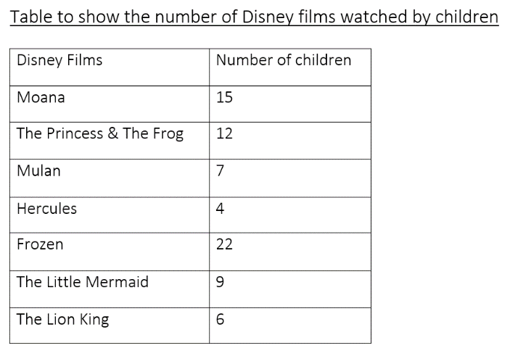
 | Foundation subject | Science – What is the difference between night and day?  https://classroom.thenational.academy/lessons/what-is-the-difference-between-night-and-day-60wp2c
 | PE link | Ninja Now Workout  https://www.youtube.com/watch?v=AL-7GGNploo
Day 3: | Subject:
 | Literacy | To develop a rich understanding of words associated with the jungle  https://classroom.thenational.academy/lessons/to-develop-a-rich-understanding-of-words-associated-with-the-jungle-part-1-6wu3gt
 | Maths | Interpreting data from your pictogram  Using your pictogram that you created yesterday answer the following questions.  - Which film was the most popular?  - Which two films were the least popular?  - Which films were watched by more than 10 children?  - What is the difference between Frozen and the Princess and The Frog?  - How many more children watched Moana than Hercules?  - Which two films add up to make a total of 13?
 | Foundation subject | Topic – Which animals lived in prehistoric Britain?  https://classroom.thenational.academy/lessons/which-animals-lived-in-prehistoric-britain-cgw6cd
 | PE link | Kids Yoga based on Movies Marathon  https://www.youtube.com/watch?v=4dxg1Sp4Q0g
Day 4: | Subject:
 | Literacy | To develop vocabulary to describe  https://classroom.thenational.academy/lessons/to-develop-vocabulary-to-describe-the-portia-spider-6xjk2c
 | Maths | Create your own bar chart  Using your knowledge about bar charts to create a chart for the following set of data.  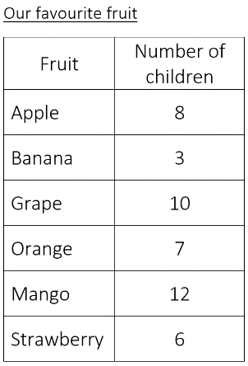
 | Foundation subject | RE – Islamic Festivals  http://twinkl.co.uk/go  Twinkl code: EG0264
 | PE link | Mario Video Game Workout  https://www.youtube.com/watch?v=pT5Cd-JNDAY
Day 5: | Subject:
 | Literacy | To plan the first section of a report  https://classroom.thenational.academy/lessons/to-plan-the-first-section-of-a-report-64tkac
 | Maths | Interpreting data from your bar chart  Using your bar chart that you created yesterday answer the following questions.  Using your bar chart answer the following questions:  - Which fruit is the most popular?  - How many children liked Banana and Strawberry?  - Which fruit was the least popular after Banana?  - What is the difference between Mango and Grape?  - How many more children preferred Mango to Banana?
 | Foundation subject | Science – Which materials are reflective?  https://classroom.thenational.academy/lessons/which-materials-are-reflective-6cu6cc
 | PE link | PhysEdZone – Dance Monkey PE Dance Warm up  https://www.youtube.com/watch?v=HkwTDyR84Ao

