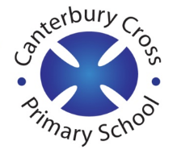
Remote Learning Year: 2 Week beginning: 17.01.22

Email address to return completed work to:
2A remotelearning2a@cantcros.bham.sch.uk
2E remotelearning2e@cantcros.bham.sch.uk

Day 1: | Subject:
 | Literacy | Information Text
 | Maths | Measure
 | Foundation subject  Music | What is a habitat?
 | PE link | Cosmic Yoga
Day 2: | Subject:
 | Literacy | Information Text
 | Maths | Measure
 | Foundation subject  Science | Judaism
 | PE link | Joe Wicks Active 8
Day 3: | Subject:
 | Literacy | Information Text
 | Maths | Measure
 | Foundation subject RE | Art
 | PE link | We are going on a bear hunt yoga
Day 4: | Subject:
 | Literacy | Information Text
 | Maths | Measure
 | Foundation subject  Art | Music
 | PE link | Active 8 with Joe Wicks
Day 5: | Subject:
 | Literacy | Information text
 | Maths | Measure
 | Foundation subject History | Great Fire of London
 | PE link | Active 8 with Joe Wicks

