Remote Learning Year: 6 Week beginning: 07.03.22

Email address to return completed work to:
6A remotelearning6a@cantcros.bham.sch.uk
6D remotelearning6d@cantcros.bham.sch.uk

Day 1: | Subject:
 | Literacy | Click and enlarge to complete task.  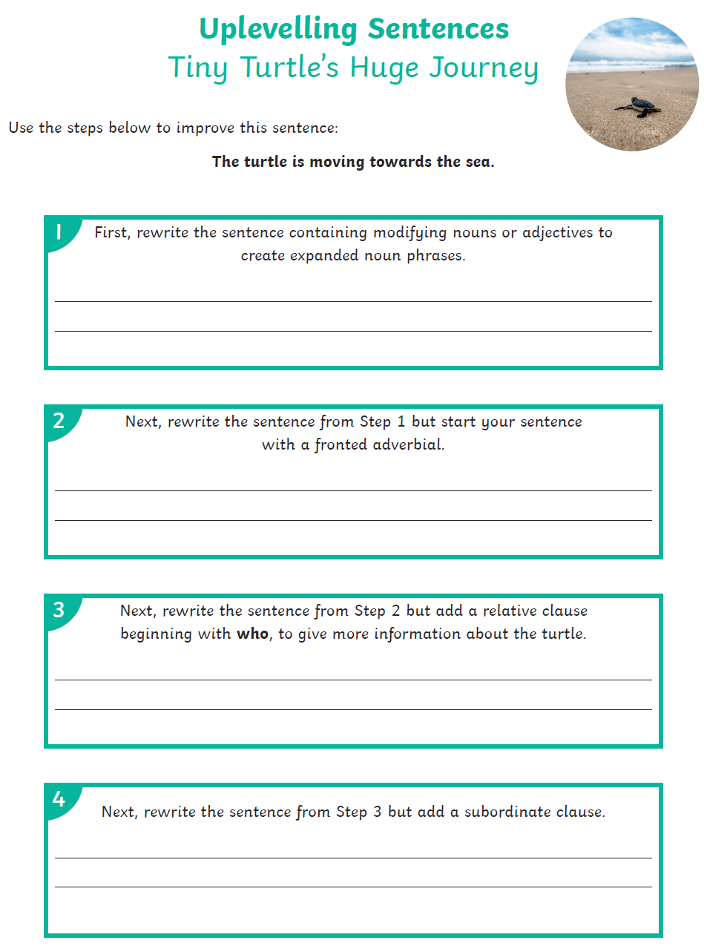
 | Maths | Click and enlarge to complete task.  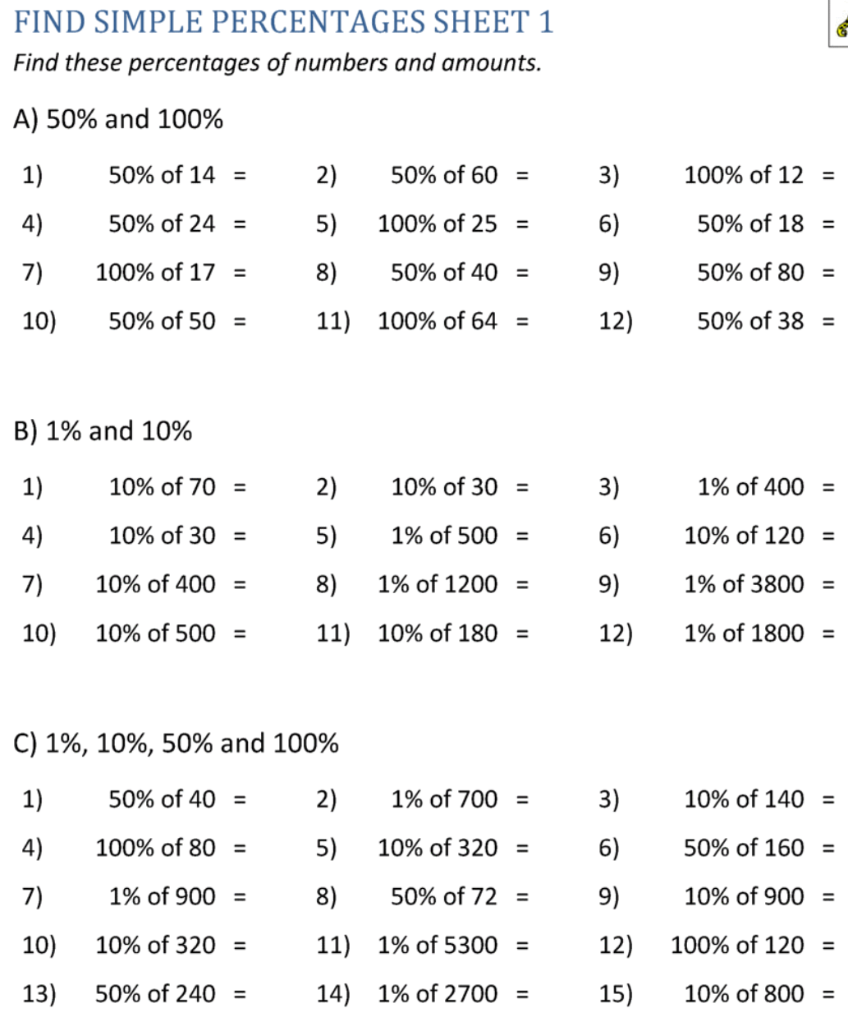
 | Foundation subject  Art | How to draw Spiderman  https://www.youtube.com/watch?v=cvESbL06ETM
 | PE link | Spiderman kids workout  https://www.youtube.com/watch?v=RLbG3gZIwEo
Day 2: | Subject:
 | Literacy | Click and enlarge to complete task.  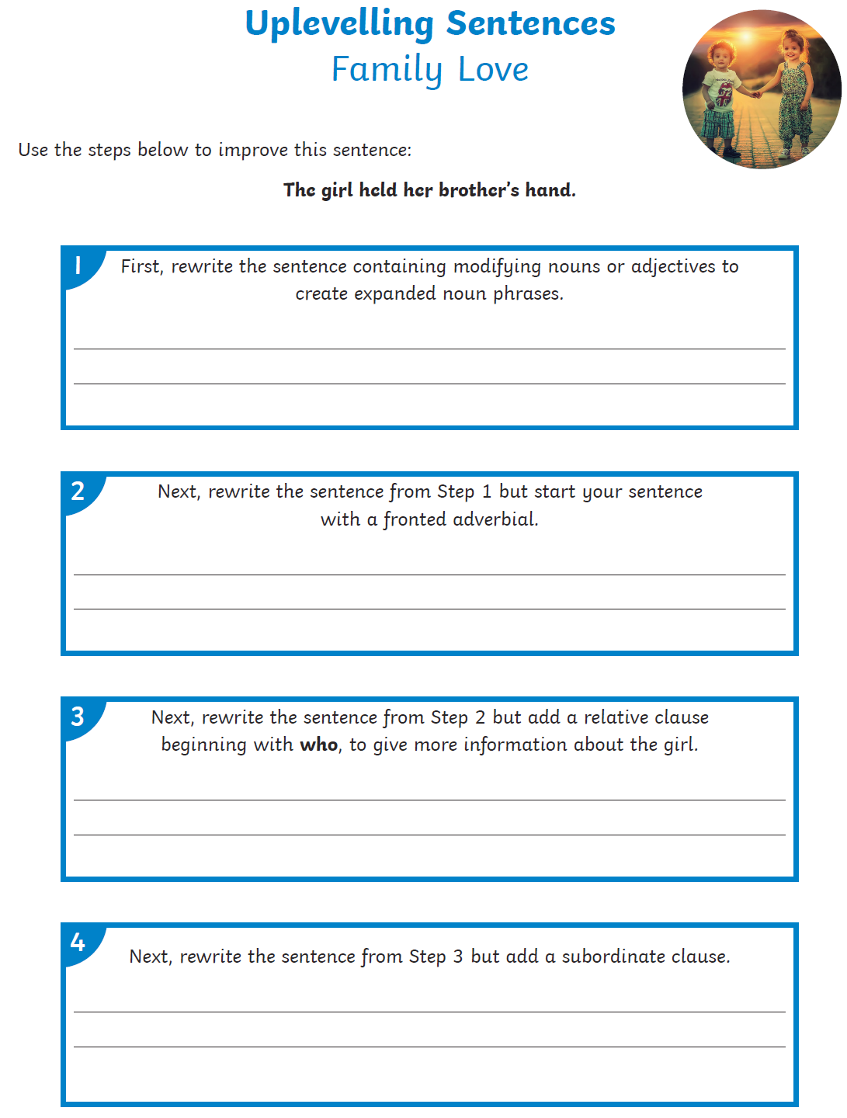
 | Maths | Click and enlarge to complete task.  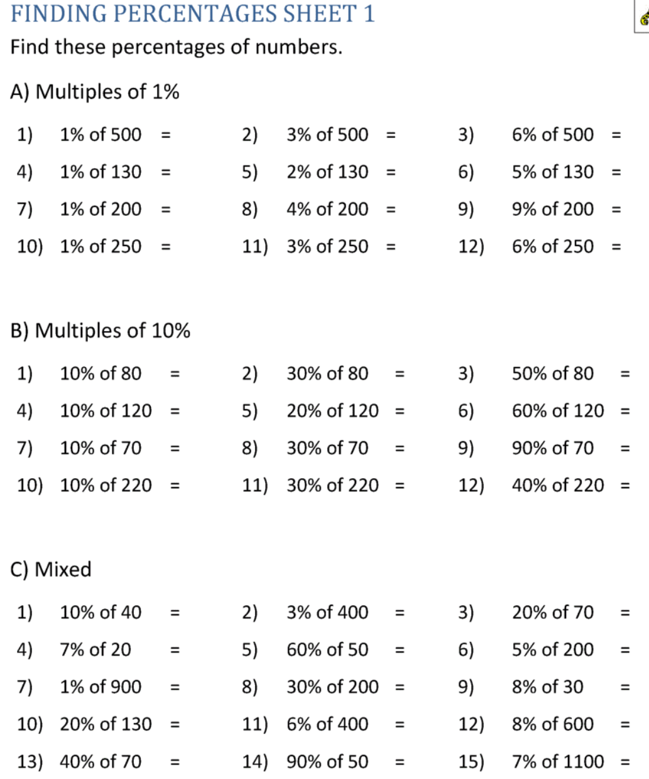
 | Foundation subject  PSHE | Men and women at work  https://classroom.thenational.academy/lessons/men-and-women-at-work-c8v3et
 | PE link | Exercise for kids  https://www.youtube.com/watch?v=oc4QS2USKmk
Day 3: | Subject:
 | Literacy | Click and enlarge to complete task.  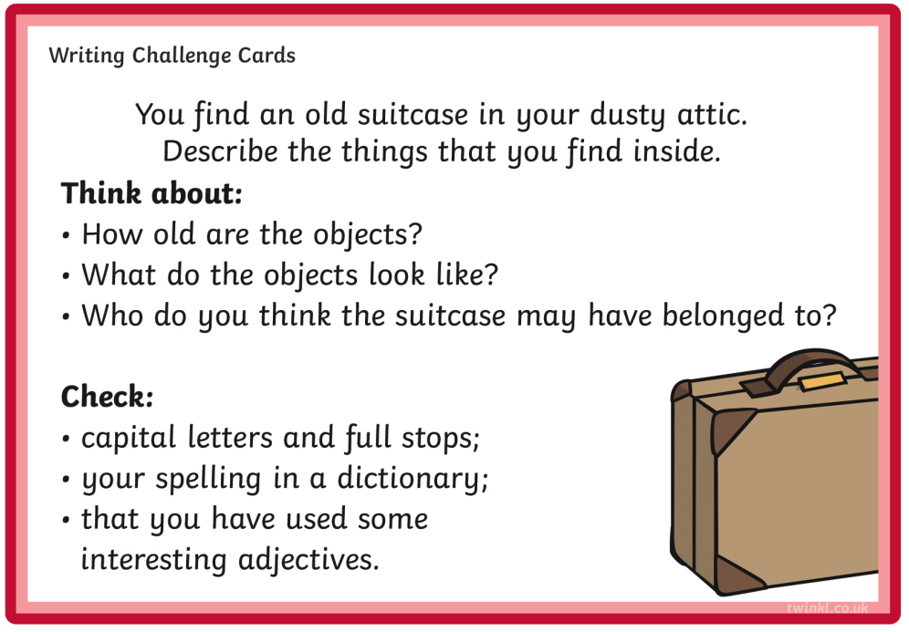
 | Maths | Click and enlarge to complete task.  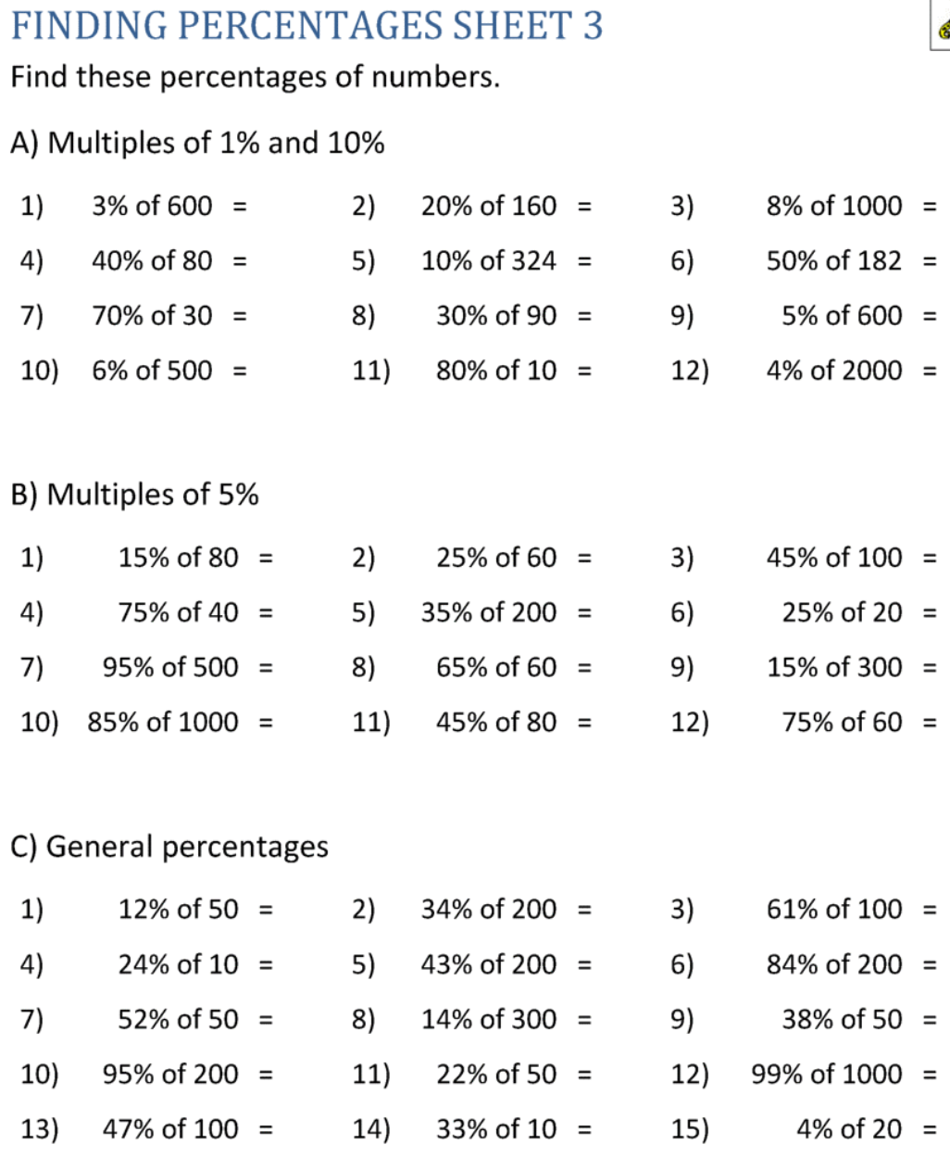
 | Foundation subject  Science | History of Science - has our understanding and use of electricity developed?  https://classroom.thenational.academy/lessons/how-has-our-understanding-and-use-of-electricity-developed-6rw68t
 | PE link | Yoga freeze dance 2  https://www.youtube.com/watch?v=6CAlcBFADFI
Day 4: | Subject:
 | Literacy | Click and enlarge to complete task.  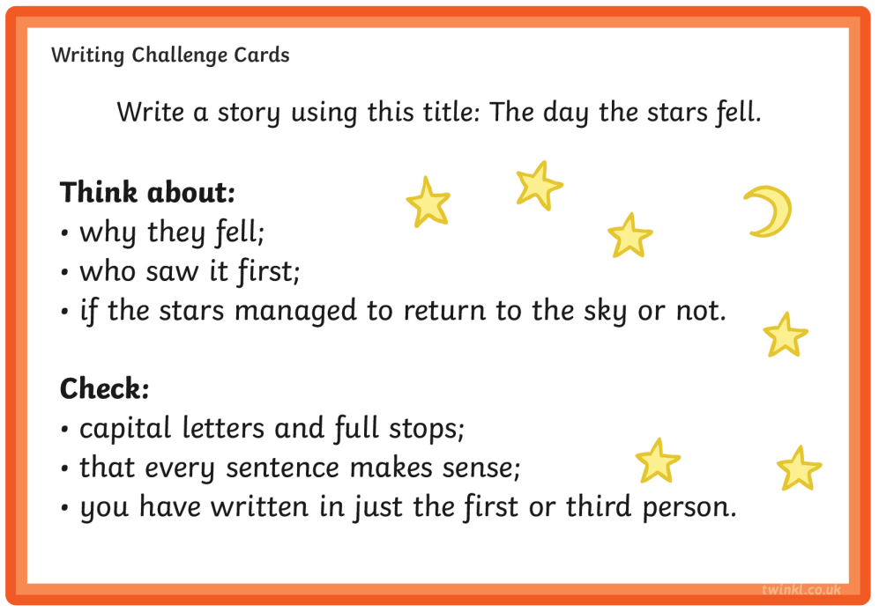
 | Maths | Click and enlarge to complete task.  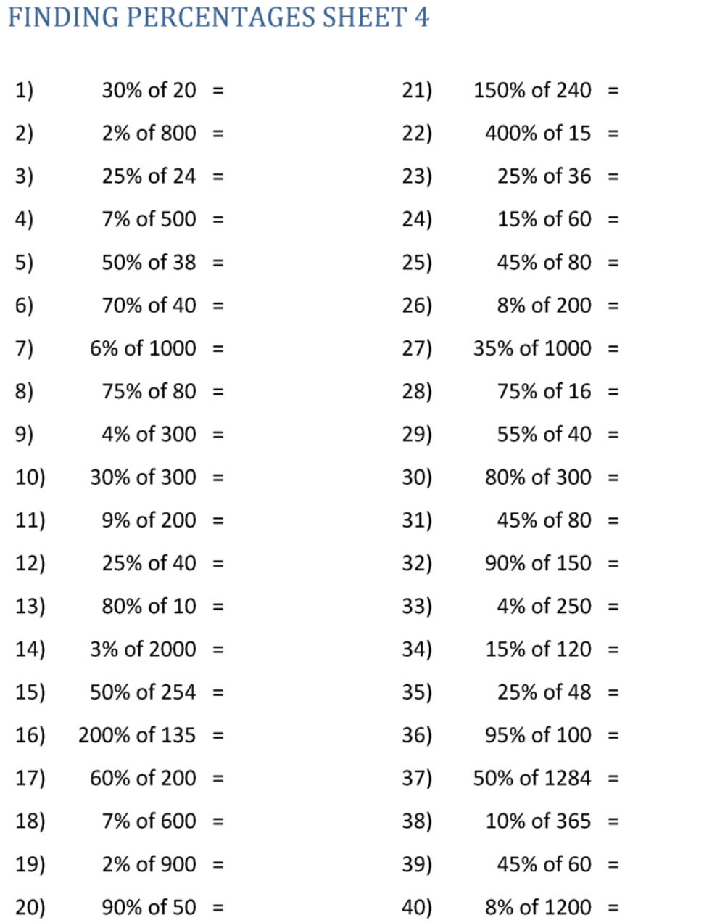
 | Foundation subject  Science | History of Science – how has human use of materials changed over time?  https://classroom.thenational.academy/lessons/how-has-human-use-of-materials-changed-over-time-6dhpcr
 | PE link | Kids exercises  https://www.youtube.com/watch?v=dQ_PK7Z-vv4
Day 5: | Subject:
 | Literacy | Click and enlarge to complete task.  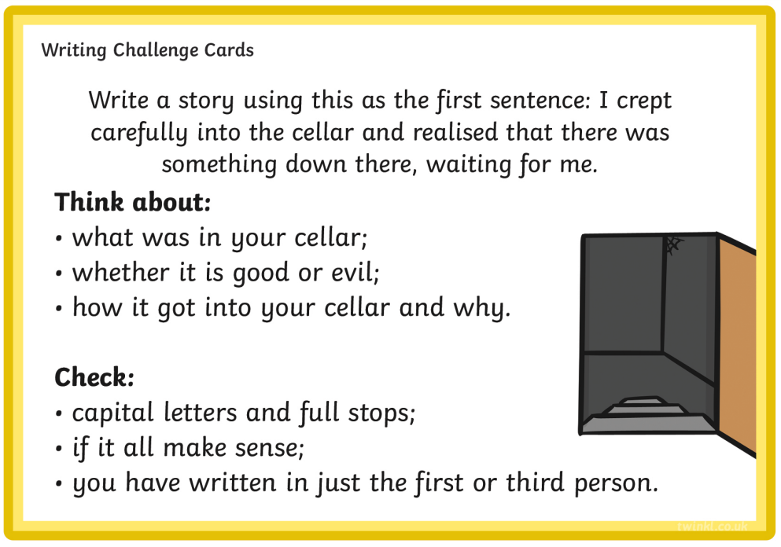
 | Maths | Arithmetic  https://myminimaths.co.uk/year-6-arithmetic-practice-paper-week-17/
 | Foundation subject  Art | How To Draw A Lamborghini Huracan  https://www.youtube.com/watch?v=Dqxesak1ESI
 | PE link | Red Light, Green Light dance party  https://www.youtube.com/watch?v=2tRCBPk4NMQ

