Remote Learning Year: 6 Week beginning: 10.01.22

Email address to return completed work to:
6A remotelearning6a@cantcros.bham.sch.uk
6D remotelearning6d@cantcros.bham.sch.uk

Day 1: | Subject:
 | Literacy | Balanced arguments (discussion texts)  Become familiar with our new topic by reading this text and identifying what features are used.  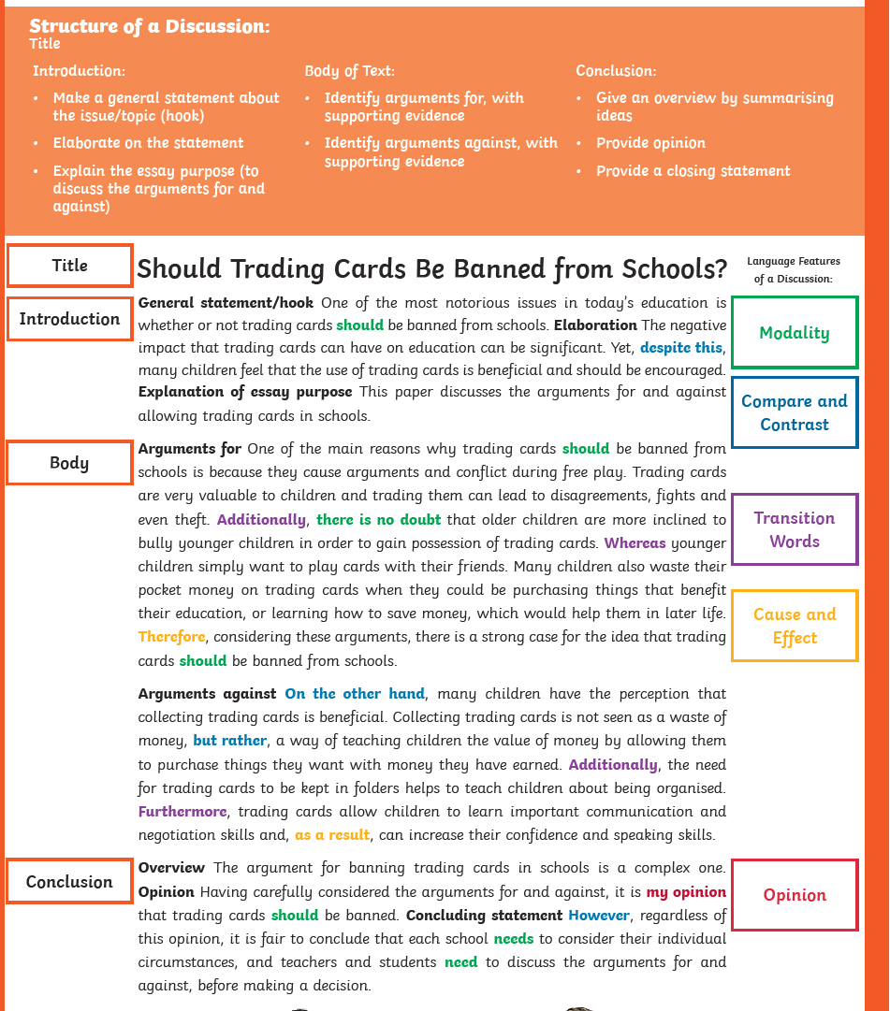
 | Maths | Add fractions  https://classroom.thenational.academy/lessons/add-fractions-cnk3ar
 | Foundation subject | Spanish – definite and indefinite articles  https://www.bbc.co.uk/bitesize/topics/zvhxt39/articles/zrqnm39
 | PE link | Hey Duggee and Joe Wicks – Bounce badge  https://www.youtube.com/watch?v=crJhc6gPaYQ
Day 2: | Subject:
 | Literacy | Balanced arguments – Use the checklist to identify features in the given text. Click and enlarge the image to complete the task.  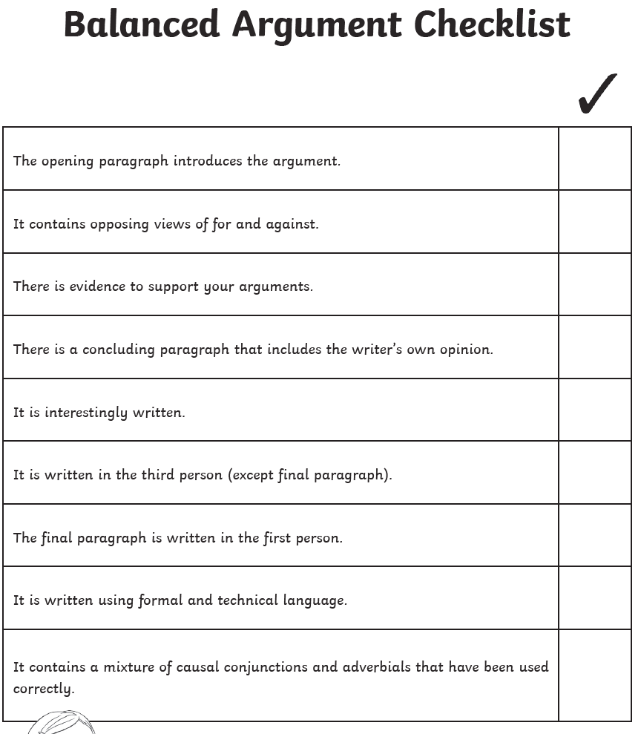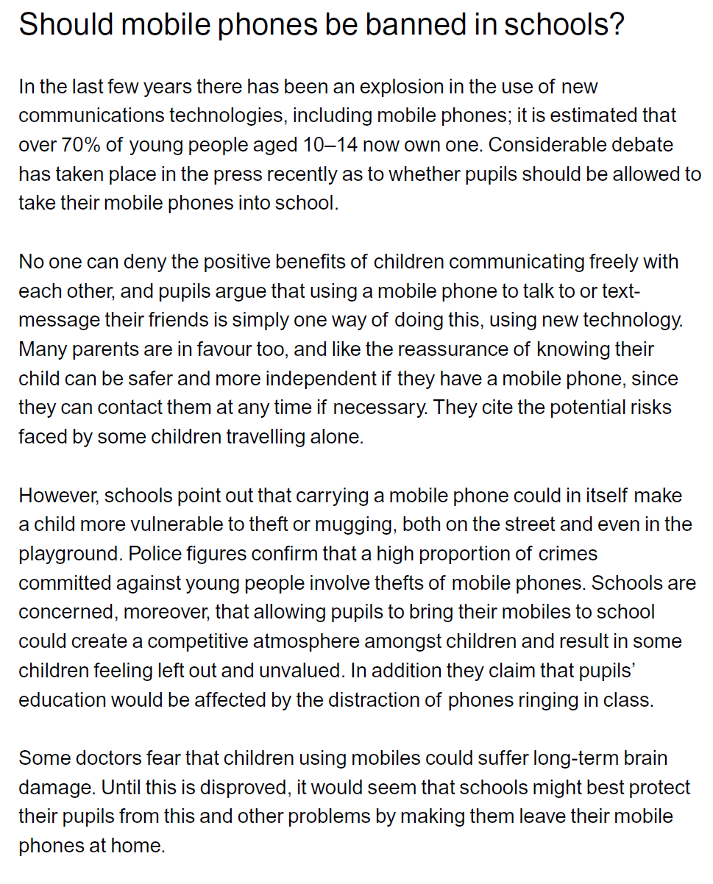
 | Maths | Subtract fractions  https://classroom.thenational.academy/lessons/subtract-fractions-6hh66r
 | Foundation subject | Music – understanding basic musical notation  https://classroom.thenational.academy/lessons/understanding-basic-notation-6rrkcr
 | PE link | Hey Duggee and Joe Wicks – Power burst  https://www.youtube.com/watch?v=jhLu_flkjgs&list=PLyCLoPd4VxBvIsxs4yYGusHvaTq9vhN0H&index=11
Day 3: | Subject:
 | Literacy | Conjunctions are a language feature of Balanced Arguments. Use the conjunctions mat to help you find and identify how conjunctions have been used in the accompanying text. Click and enlarge the image to complete the task.  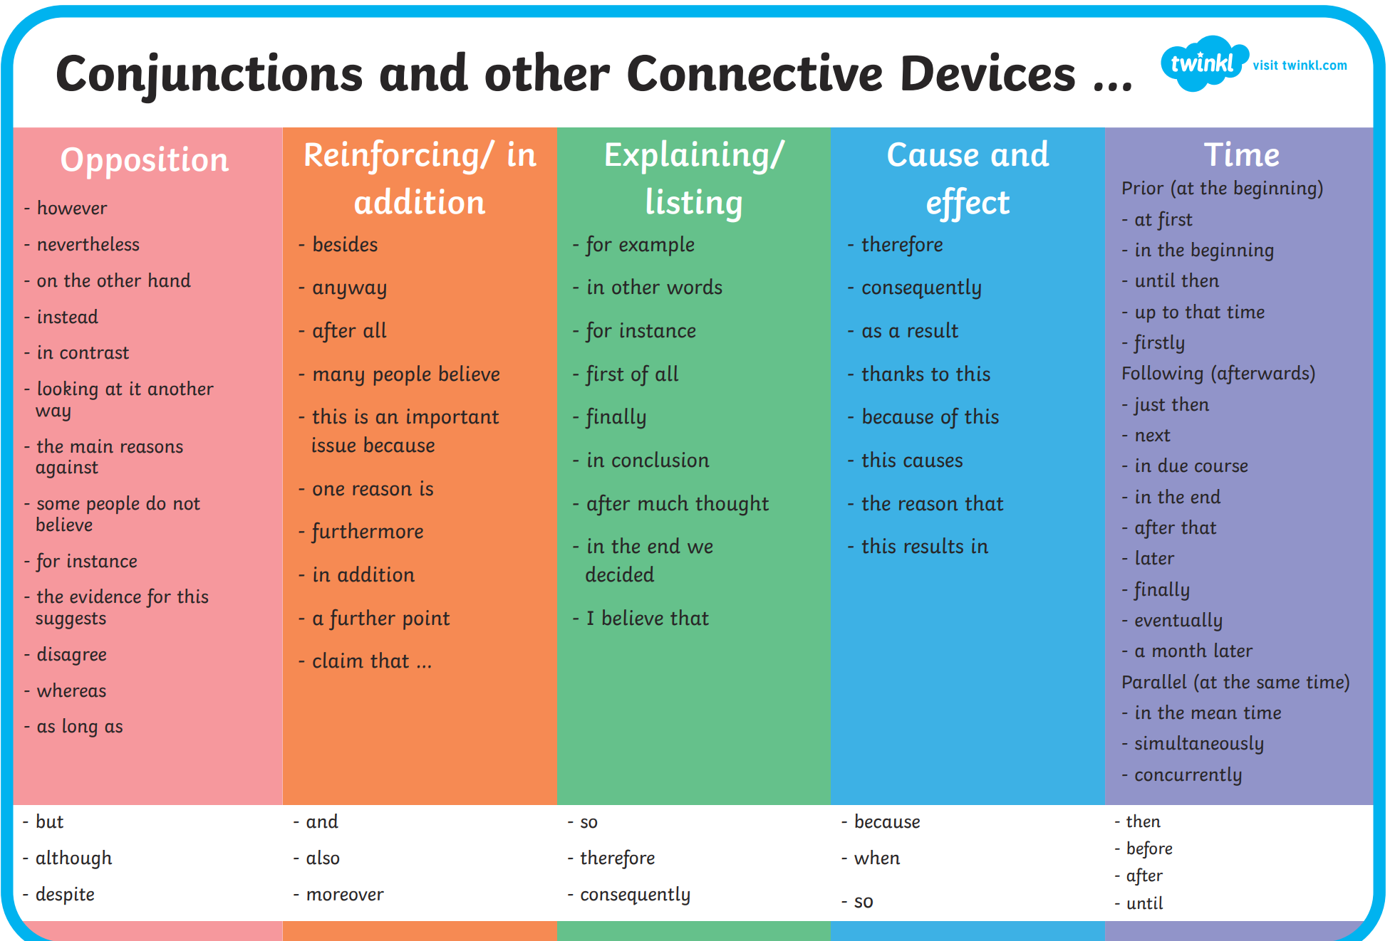
 | Maths | Fractions problem solving  https://classroom.thenational.academy/lessons/fractions-problem-solving-c9k38d
 | Foundation subject | RE – where and how do Sikhs worship?  https://classroom.thenational.academy/lessons/where-and-how-do-sikhs-worship-cguk4r
 | PE link | Active 8 Minute Workout 1  https://www.youtube.com/watch?v=YIB2SJnBHBQ
Day 4: | Subject:
 | Literacy | Using the title – Should homework be banned?, research arguments for and against this topic using the internet.  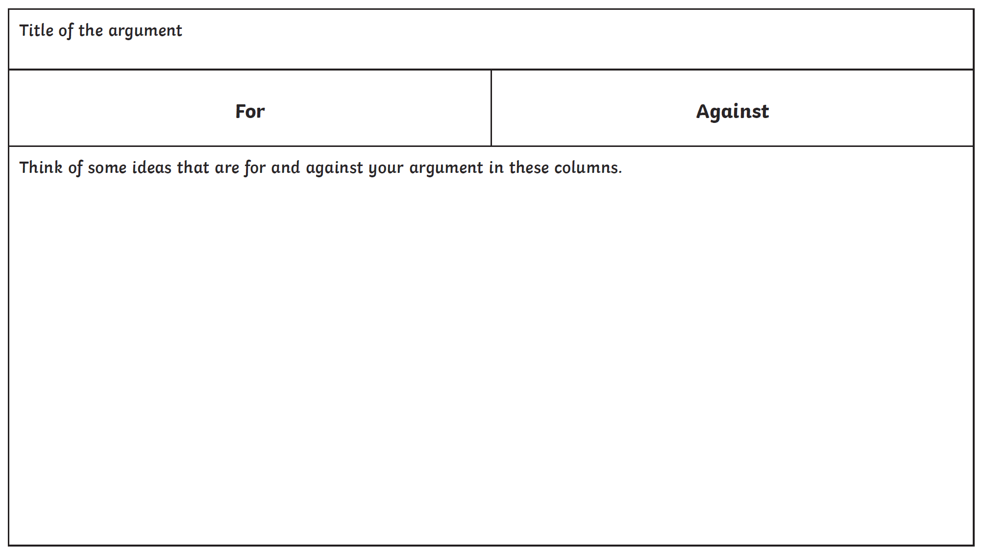
 | Maths | Click and enlarge the image to complete the task.  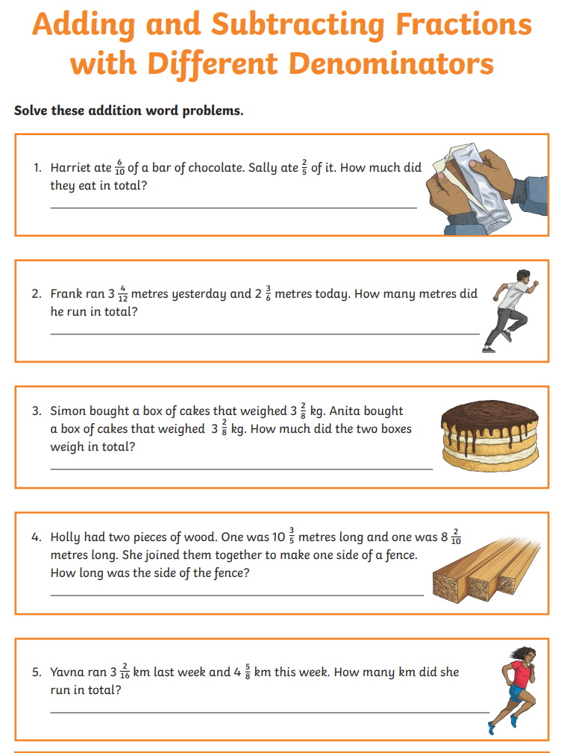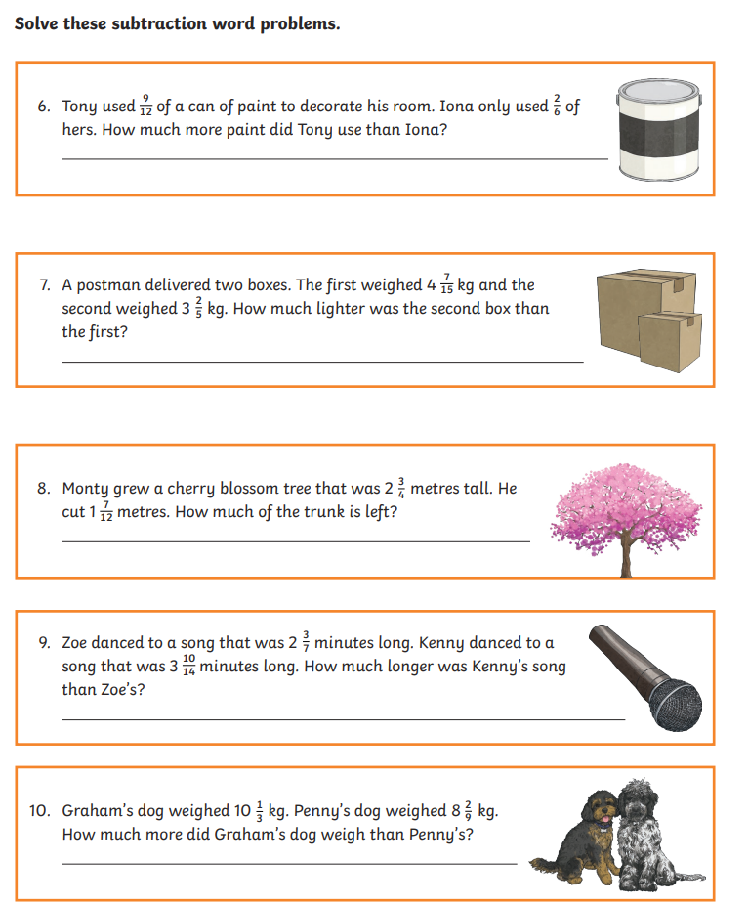
 | Foundation subject | PSHE – beautiful explosions  You will learn about keeping safe around bonfires / fireworks  https://classroom.thenational.academy/lessons/beautiful-explosions-6hh3gt
 | PE link | Active 8 Minute Workout 2  https://www.youtube.com/watch?v=EDC-plCTBbc
Day 5: | Subject:
 | Literacy | Using your research from yesterday, begin to write your Balanced Argument using the word mat to help with connecting ideas. Click and enlarge the image to complete the task.  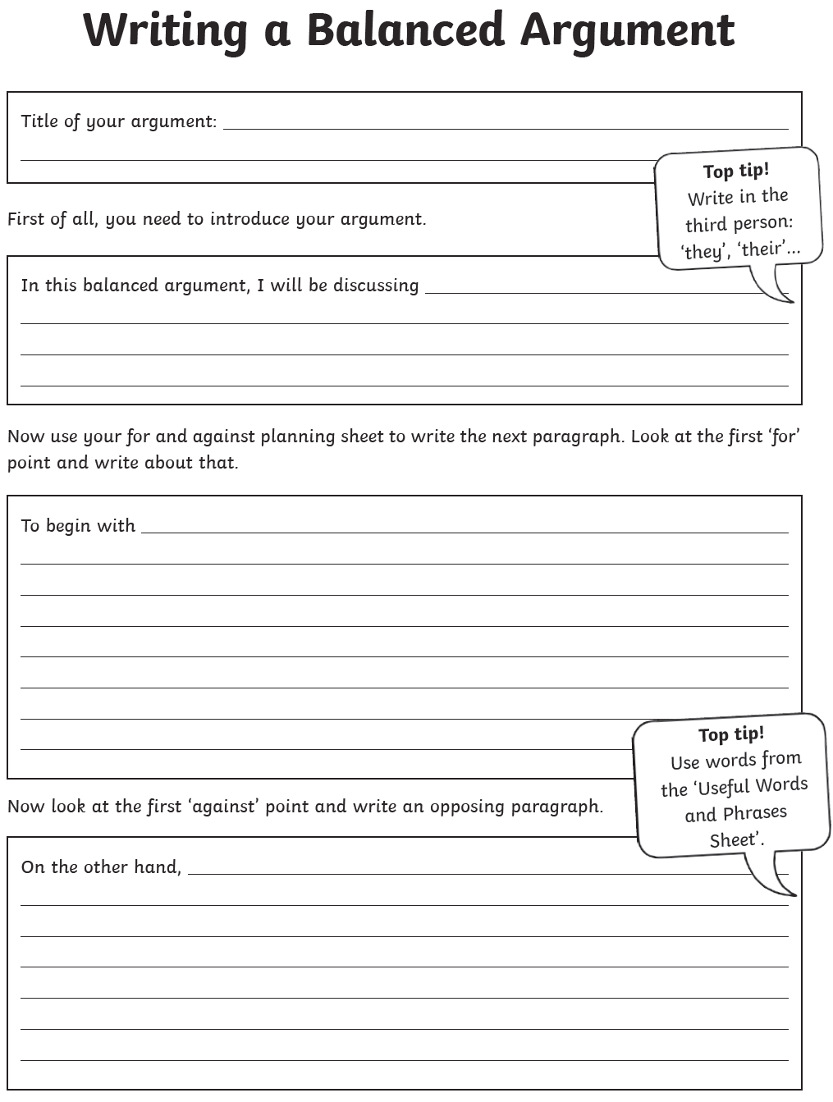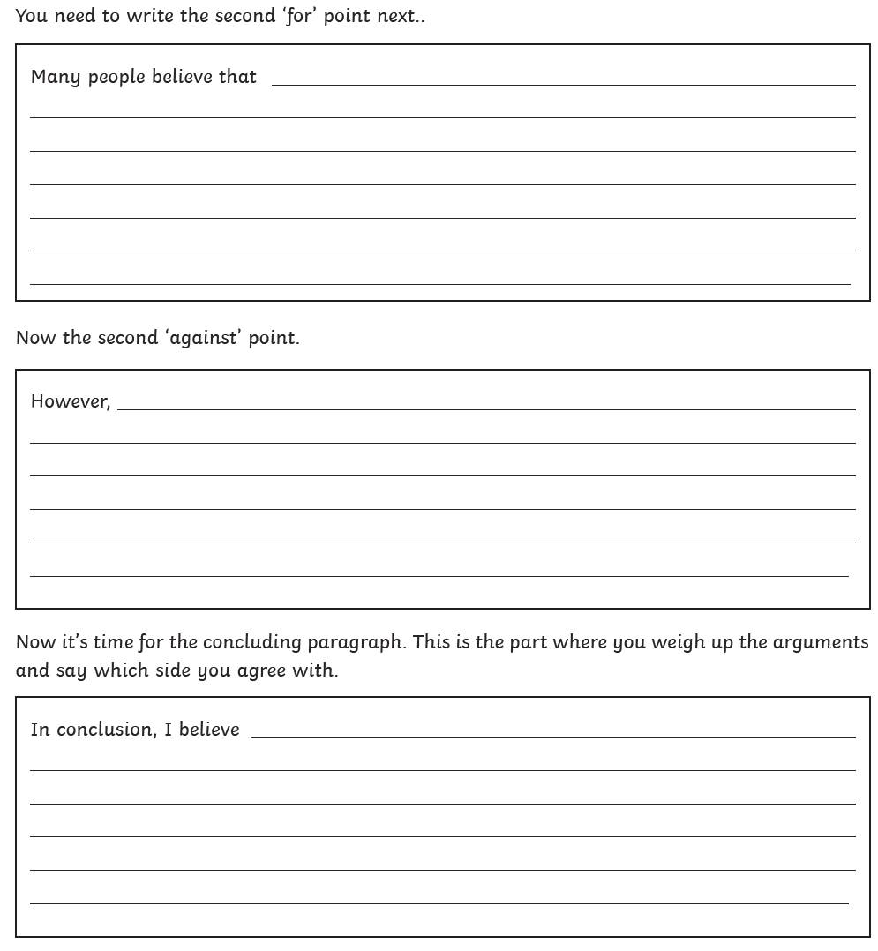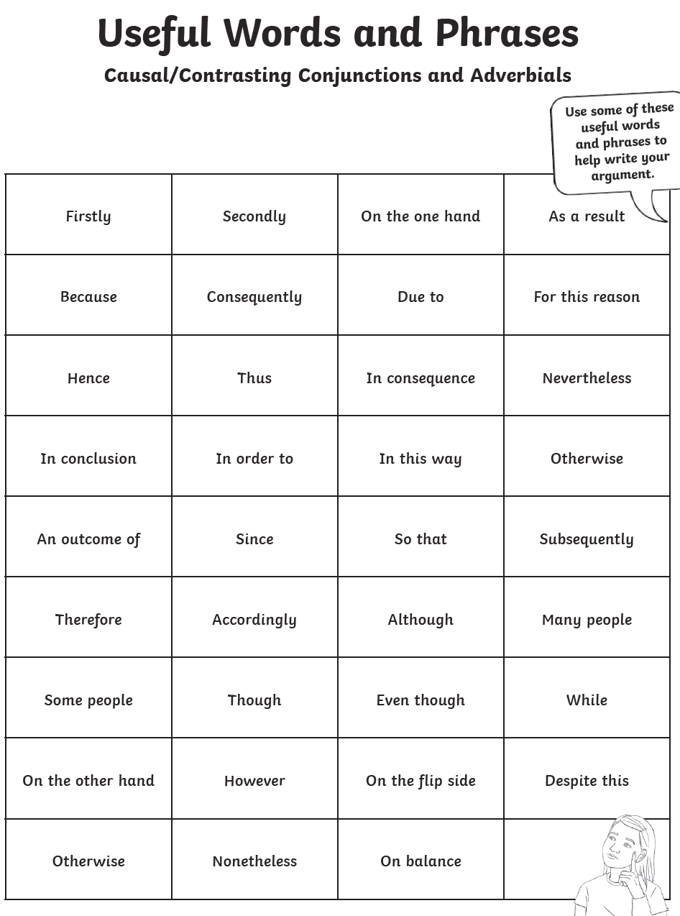
 | Maths | 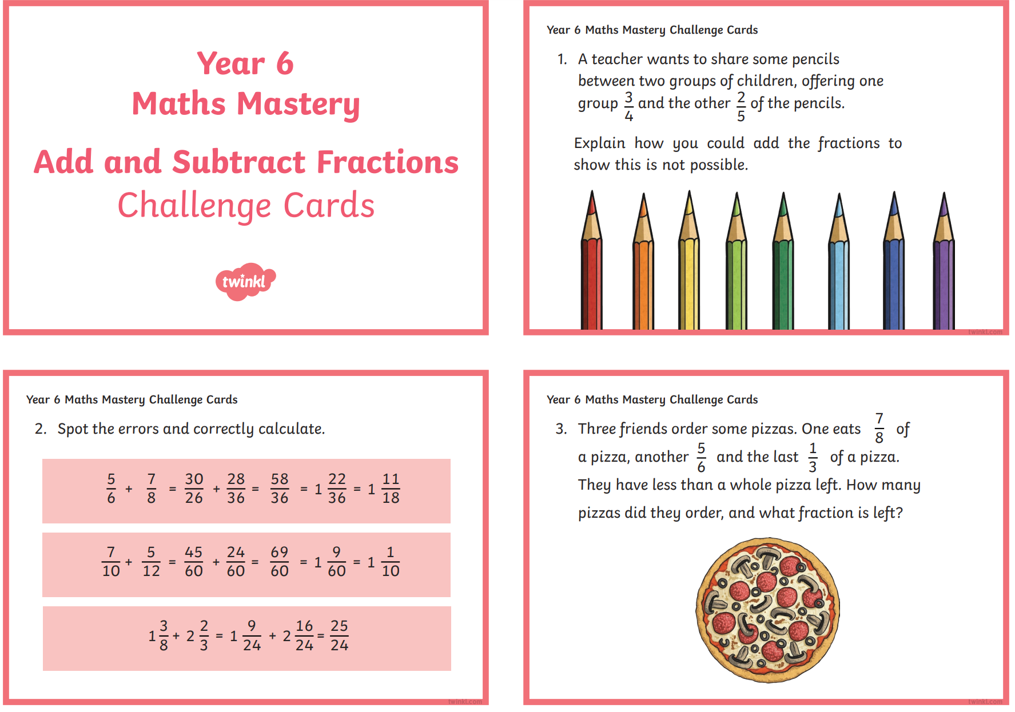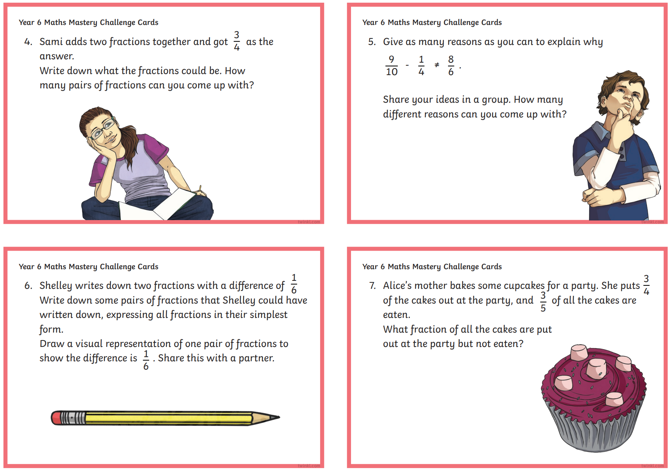
 | Foundation subject  PSHE | Art – Follow the tutorial to draw a crocodile  https://www.youtube.com/watch?v=38RQ68EufHo
 | PE link | Energising workout  https://www.youtube.com/watch?v=5MBEyQIlrfo&list=PLyCLoPd4VxBuxu3sLztrvWFehzv-LnR2c&index=7

