Remote Learning Year: 3 Week beginning: 20.09.2021

Email address to return completed work to:
3S remotelearning3S@cantcros.bham.sch.uk
3G remotelearning3G@cantcros.bham.sch.uk

Monday: | Subject:
 | Literacy | Explore stories with familiar settings  What does familiar mean?  What places are familiar to you?  Read through the different texts which can be found on Teams and then have a go at answering the questions below.  - What is the title?  - What is this story about? (Summary verbal)  - Where is the story set?  - Who are the characters?  - What is the problem?  - What is the resolution?
 | Maths | Finding all possible numbers that could have been rounded to a multiple of ten  https://classroom.thenational.academy/lessons/finding-all-possible-numbers-that-could-have-been-rounded-to-a-multiple-of-ten-crrp8c
 | Foundation subject | Science – Naming bones  Go through the powerpoint then complete the sheet called ‘Name those Bones!’  http://twinkl.co.uk/go  Twinkl code: EG5412
 | PE link | Dance - Extreme Earth  Volcanic Eruption  http://twinkl.co.uk/go  Twinkl code: EG5032
Tuesday: | Subject:
 | Literacy | Identify language features in a story  On Teams you will find a copy of the passage that we are going to look at today and tomorrow.  What features of a story do you already know?  Read through the paragraph and make a note of words you are unsure of and look up the definitions.  Then underline words or phrases that help you answer the questions below.  - What do we learn about the boy?  - How is this shown?  Think about the different word classes to help you (adjectives, verbs, similes)
 | Maths | Rounding 2 and 3 digit numbers to the nearest 100  https://classroom.thenational.academy/lessons/rounding-2-and-3-digit-numbers-to-the-nearest-100-ctgpar
 | Foundation subject | Science – Functions of a Skeleton  Go through the powerpoint then complete the sheet called ‘Skeleton Functions’  http://twinkl.co.uk/go  Twinkl code: EG5412
 | PE link | Dance – Extreme Earth  Rumble and Shake  http://twinkl.co.uk/go  Twinkl code: EG5032
Wednesday: | Subject:
 | Literacy | Identify language features in a story  On Teams you will find a copy of the passage that we looked at yesterday.  Today’s work is similar to yesterday with a focus on setting.  Underline words or phrases that help you answer the questions below.  - What do we learn about the setting?  - How is this detail added?  - How is repetition avoided?  - Why is this important?  Remember to think about the different word classes to help you (adjectives, verbs, adverbs)
 | Maths | Applying place value knowledge to problem solving  https://classroom.thenational.academy/lessons/applying-place-value-knowledge-to-problem-solving-71jket
 | Foundation subject | Topic – The rainforest climate  Go through the powerpoint and then complete the sheet ‘Rainforest Weather Forecast’  http://twinkl.co.uk/go  Twinkl code: EG0786
 | PE link | Dance – Extreme Earth  Tsunami  http://twinkl.co.uk/go  Twinkl code: EG5032
Thursday:
 | Literacy | Develop initial responses  https://classroom.thenational.academy/lessons/to-develop-initial-responses-cgvp2d
 | Maths | Finding solutions to a problem  https://classroom.thenational.academy/lessons/finding-solutions-to-a-problem-c4t38c
 | Foundation subject | RE – What gift would you give to the world?  Christmas is the celebration of Jesus’ birthday. Jesus was gifted to the world from God because God wanted to teach people about the truth of his Kingdom and bring peace to all the Earth.  Chn to choose a gift that they would like to give to the world today.  What would it be? Why?
 | PE link | Dance – Extreme Earth  Tornadoes!  http://twinkl.co.uk/go  Twinkl code: EG5032
Friday: | Subject:
 | Literacy | -y suffix  https://classroom.thenational.academy/lessons/to-investigate-suffixes-y-suffix-cmu36r
 | Maths | Place value application lesson  https://classroom.thenational.academy/lessons/place-value-application-lesson-6dk3er
 | Foundation subject | Art – tints and shades  Using the colour wheel that you created last week draw a smaller circle inside and a larger circle outside – look at the example below if you are unsure.  Use paint if you have or colouring pencils.  This lesson will be looking at tints and shades.  Shades are when we take our hue and mix it with black to create a darker colour.  Tints are when we take our hue and mix it with white to create a lighter colour.  Start with your primary colours, then move onto your secondary and lastly tertiary.  For example:  Choose red and a small amount of black to create your shade and place on the outside part of your circle.  Then select your initial red and add a small amount of white to create your tint and place on the outside part of your circle.  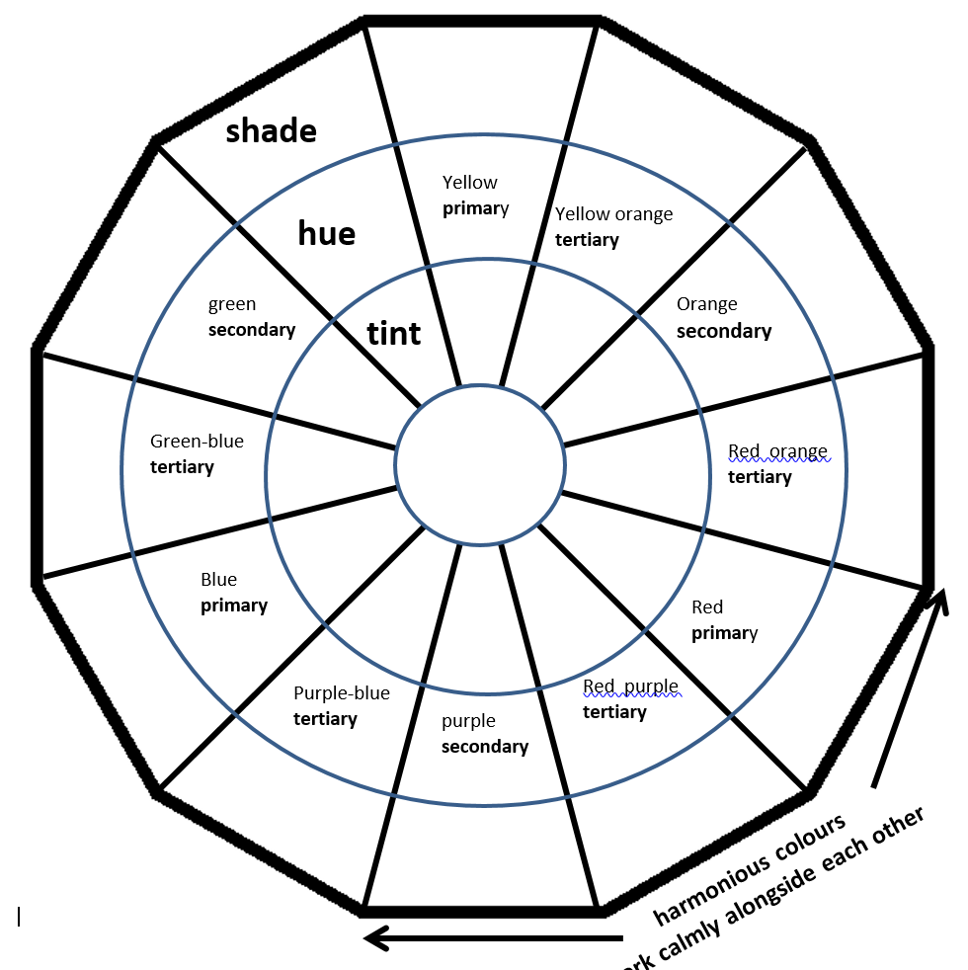
 | PE link | Dance – Extreme Earth  Effects of Natural Disasters  http://twinkl.co.uk/go  Twinkl code: EG5032

