Remote Learning Year: 6 Week beginning: 17.01.22

Email address to return completed work to:
6A remotelearning6a@cantcros.bham.sch.uk
6D remotelearning6d@cantcros.bham.sch.uk

Day 1: | Subject:
 | Literacy | Spellings – curriculum words part 1  https://classroom.thenational.academy/lessons/to-practise-curriculum-words-6tj32d
 | Maths | Represent multiplication with proper fractions  https://classroom.thenational.academy/lessons/fractions-represent-multiplication-with-proper-fractions-c9h64e
 | Foundation subject  RE | Who is Jesus?  https://classroom.thenational.academy/lessons/who-was-jesus-6mv66c
 | PE link | Traffic lights game  https://www.youtube.com/watch?v=2tRCBPk4NMQ
Day 2: | Subject:
 | Literacy | Spellings – curriculum words part 2  https://classroom.thenational.academy/lessons/to-practise-and-apply-knowledge-of-curriculum-words-including-test-65k6ar
 | Maths | Multiply pairs of proper fractions  https://classroom.thenational.academy/lessons/fractions-multiply-pairs-of-proper-fractions-c4rp4r
 | Foundation subject  History | Was Elizabeth I weak and feeble?  https://classroom.thenational.academy/lessons/was-elizabeth-i-weak-and-feeble-crwk4t
 | PE link | Just dance workout  https://www.youtube.com/watch?v=yQ4fTl4wbko
Day 3: | Subject:
 | Literacy | Year 5 and 6 Statutory spellings. Click and enlarge the image to complete the task.  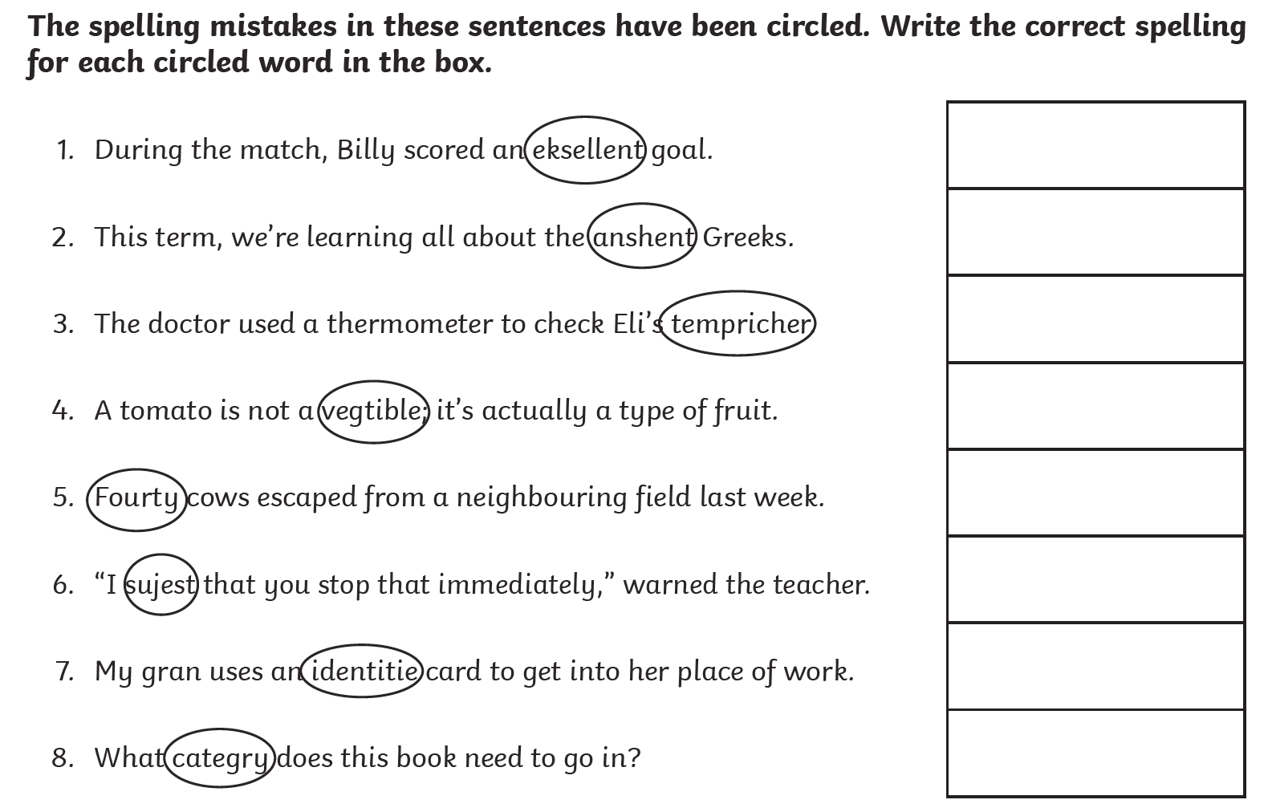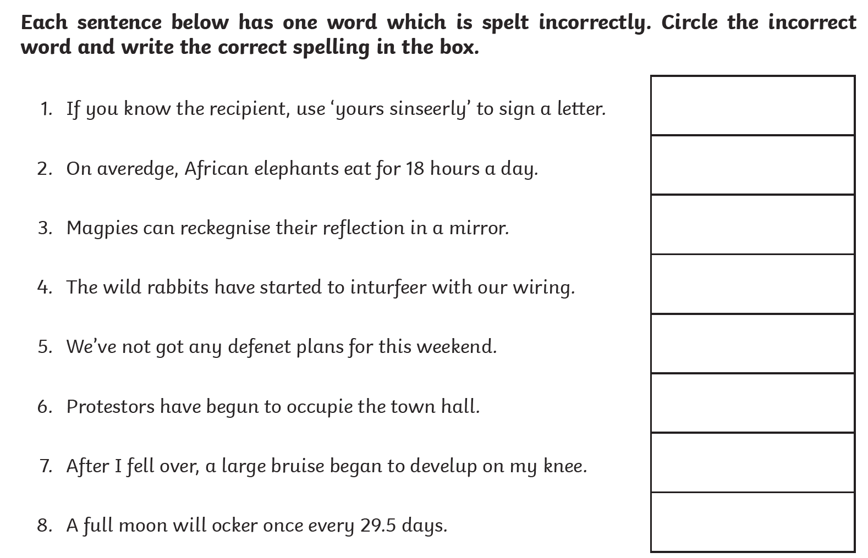
 | Maths | Divide a proper fraction by an integer  https://classroom.thenational.academy/lessons/fractions-divide-a-proper-fraction-by-an-integer-6tjkgd
 | Foundation subject  Science | Which materials are reflective?  https://classroom.thenational.academy/lessons/which-materials-are-reflective-6cu6cc
 | PE link | Get active at home  https://www.youtube.com/watch?v=3_oIssULEk0
Day 4: | Subject:
 | Literacy | Practise applying your SPAG skills to these short activities. Click and enlarge the image to complete the task.  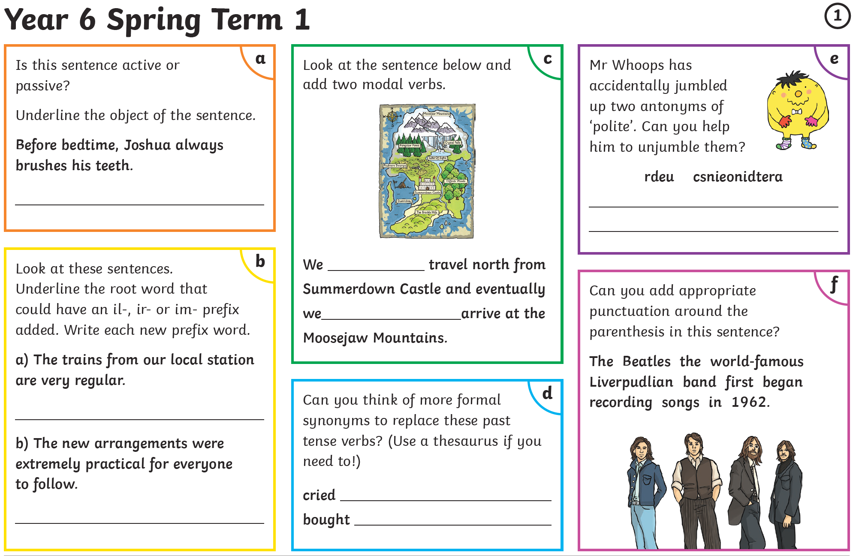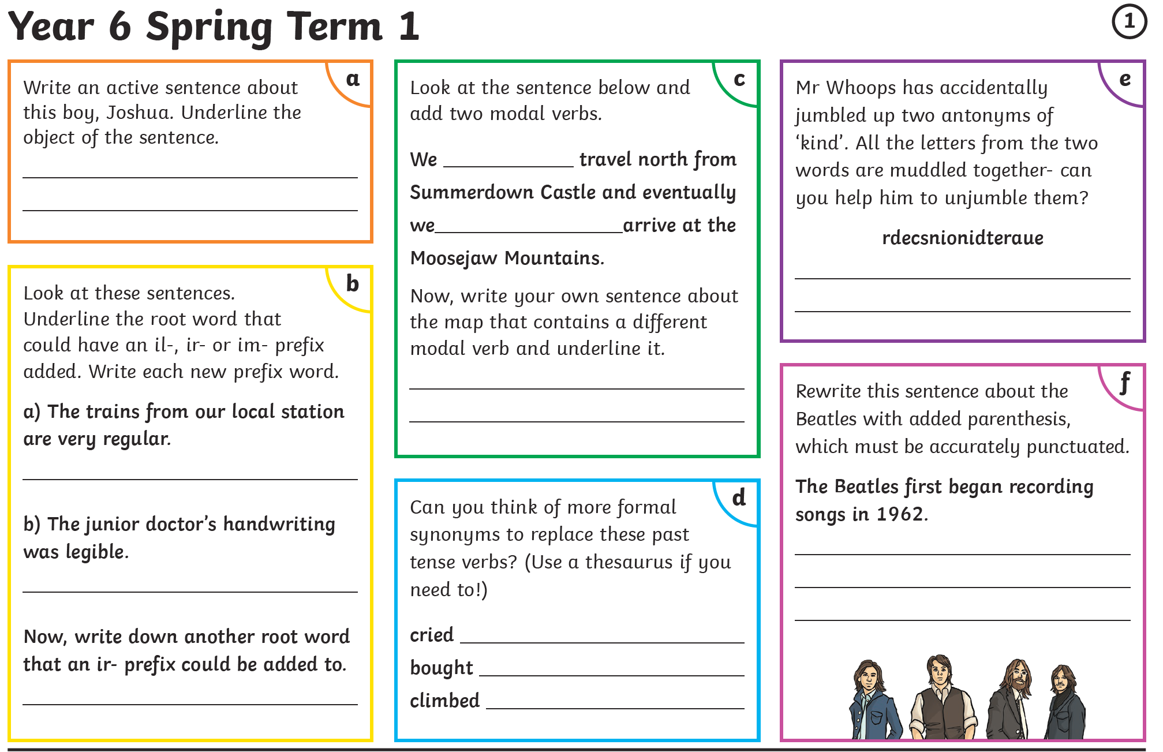
 | Maths | Multiply and divide with improper fractions  https://classroom.thenational.academy/lessons/fractions-multiply-and-divide-with-improper-fractions-74tk8c
 | Foundation subject  PSHE | Deforestation  https://classroom.thenational.academy/lessons/deforestation-70vk0c
 | PE link | Cosmic yoga  https://www.youtube.com/watch?v=KAT5NiWHFIU
Day 5: | Subject:
 | Literacy | Modal verbs  https://classroom.thenational.academy/lessons/to-explore-modal-verbs-c9k34d
 | Maths | Solve fraction problems with the four operations  https://classroom.thenational.academy/lessons/fractions-solve-fraction-problems-with-the-four-operations-cgrk0d
 | Foundation subject  Art | Sculpting in clay  https://classroom.thenational.academy/lessons/sculpting-in-clay-c4w6cc
 | PE link | PE with Joe  https://www.youtube.com/watch?v=tSi2ix1i180

