Remote Learning Year: 6 Week beginning: 31.01.22

Email address to return completed work to:
6A remotelearning6a@cantcros.bham.sch.uk
6D remotelearning6d@cantcros.bham.sch.uk

Day 1: | Subject:
 | Literacy | The Giant's Necklace by Michael Morpurgo  https://classroom.thenational.academy/lessons/to-engage-with-the-text-cmwkjr
 | Maths | FDP – second sheet. Click to watch the video then do Q8.  chrome-extension://efaidnbmnnnibpcajpcglclefindmkaj/viewer.html?pdfurl=https%3A%2F%2Fcorbettmaths.com%2Fwp-content%2Fuploads%2F2018%2F11%2FFDP-Mixture-pdf.pdf&clen=3095521&chunk=true
 | Foundation subject  RE | Click and enlarge the image. Research lesson about the crucifixion.  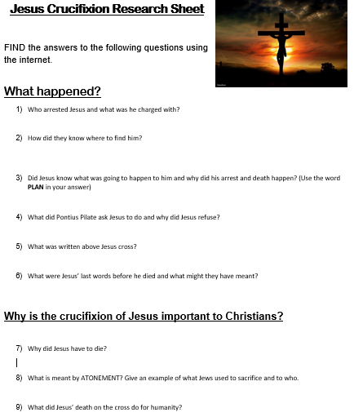
 | PE link | Traffic lights game  https://www.youtube.com/watch?v=2tRCBPk4NMQ
Day 2: | Subject:
 | Literacy | The Giant's Necklace by Michael Morpurgo  https://classroom.thenational.academy/lessons/to-read-a-text-and-make-inferences-part-1-6mr3gr
 | Maths | FDP – third sheet. Click to watch the video then do Q1-3.  chrome-extension://efaidnbmnnnibpcajpcglclefindmkaj/viewer.html?pdfurl=https%3A%2F%2Fcorbettmaths.com%2Fwp-content%2Fuploads%2F2018%2F11%2FFDP-Mixture-pdf.pdf&clen=3095521&chunk=true
 | Foundation subject  PSHE | Pearly whites  https://classroom.thenational.academy/lessons/pearly-whites-6tjked
 | PE link | Just dance workout  https://www.youtube.com/watch?v=yQ4fTl4wbko
Day 3: | Subject:
 | Literacy | The Giant's Necklace by Michael Morpurgo  https://classroom.thenational.academy/lessons/to-read-a-text-and-make-inferences-part-2-c8rp4e
 | Maths | FDP – third sheet. Click to watch the video then do Q4-6.  chrome-extension://efaidnbmnnnibpcajpcglclefindmkaj/viewer.html?pdfurl=https%3A%2F%2Fcorbettmaths.com%2Fwp-content%2Fuploads%2F2018%2F11%2FFDP-Mixture-pdf.pdf&clen=3095521&chunk=true
 | Foundation subject  Science | Watch the videos and create a poster about how shadows are formed. Include a scientific diagram.  https://www.bbc.co.uk/bitesize/clips/z6fnvcw  https://www.bbc.co.uk/bitesize/clips/z8vfb9q  https://www.bbc.co.uk/bitesize/clips/zshxpv4
 | PE link | Get active at home  https://www.youtube.com/watch?v=3_oIssULEk0
Day 4: | Subject:
 | Literacy | The Giant's Necklace by Michael Morpurgo  https://classroom.thenational.academy/lessons/to-analyse-a-setting-6rtp2e
 | Maths | FDP – third sheet. Click to watch the video then do Q7-9.  chrome-extension://efaidnbmnnnibpcajpcglclefindmkaj/viewer.html?pdfurl=https%3A%2F%2Fcorbettmaths.com%2Fwp-content%2Fuploads%2F2018%2F11%2FFDP-Mixture-pdf.pdf&clen=3095521&chunk=true
 | Foundation subject  ICT | Communicating responsibly  https://classroom.thenational.academy/lessons/communicating-responsibly-65gp8d
 | PE link | Cosmic yoga  https://www.youtube.com/watch?v=KAT5NiWHFIU
Day 5: | Subject:
 | Literacy | The Giant's Necklace by Michael Morpurgo  https://classroom.thenational.academy/lessons/to-read-comprehend-and-respond-to-a-climax-6gr68c
 | Maths | Arithmetic practise  https://myminimaths.co.uk/year-6-arithmetic-practice-paper-week-9/
 | Foundation subject  Art | POINTILLISM FOR KIDS!  https://www.youtube.com/watch?v=cFVRnE_3tG0
 | PE link | PE with Joe  https://www.youtube.com/watch?v=tSi2ix1i180

