Remote Learning Year: 3 Week beginning: 14.03.22

Email address to return completed work to:
3S remotelearning3S@cantcros.bham.sch.uk
3G remotelearning3G@cantcros.bham.sch.uk

Monday | Subject:
 | Literacy | Myths and Legends – up-level a character description  Look at this picture of the Minotaur.  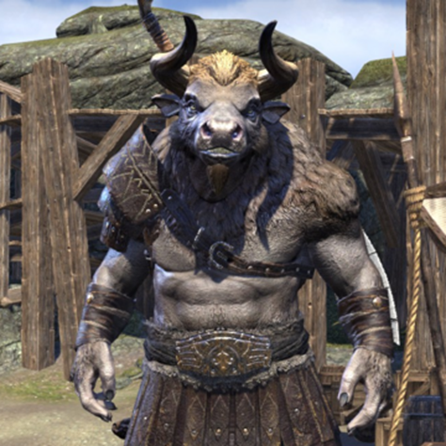  What are the features of a character description?  - Appearance  - Actions – how the character moves  - Personality  - Speech – how the character talks  Create a word bank of adjectives, verbs and adverbs that could be used to describe it.
 | Maths | Multiply 2-digits by 1-digit – exchange  https://whiterosemaths.com/homelearning?year=year-3  Make sure you select Year 3. Then choose the video labelled: Multiply 2-digits by 1-digit - exchange
 | Foundation Subject | PSHE – I role with my role  https://classroom.thenational.academy/lessons/i-roll-with-my-role-65h3gr
 | PE link | Joe Wick’s blue peter workout:  https://www.bbc.co.uk/cbbc/joinin/bp-joe-wicks-workout?collection=cbbc-top-picks-today
Tuesday | Subject:
 | Literacy | Myths and Legends – up-level a character description  Using the picture and the word bank you created yesterday.  Up-level the text below. Remember to think about:  - Appropriate adjectives  - Up-level verbs  - Spellings  - Punctuation (CL FS)  Deep inside the labyrinth lived an ugly thing called the Minotaur. Half man half bull, the Minotaur was a nasty beest Covered from head to toe in mud, blood and sweat, the smel of rotten flesh floated down the corridors in the maze. standing at over 2 metres tall, two horns poked out from the top of his hed and eyes stared down his prey making them shake in fear.
 | Maths | Multiply 2-digits by 1-digit (2)  https://whiterosemaths.com/homelearning?year=year-3  Make sure you select Year 3. Then choose the video labelled: Multiply 2-digits by 1-digit (2)
 | Foundation Subject | Topic – Mummification  Using your Ancient Egyptian knowledge so far, complete the activity pack on twinkl called:  Mummification  httpp://twinkl.co.uk/go  Twinkl code: EG9126
 | PE link | Footie tricks to learn at home:  https://www.bbc.co.uk/cbbc/watch/bp-john-farnworth-football?collection=bp-how-to-guides-curation
Wednesday
 | Literacy | Myths and Legends – plan a character description  Look at this picture of the Medusa.  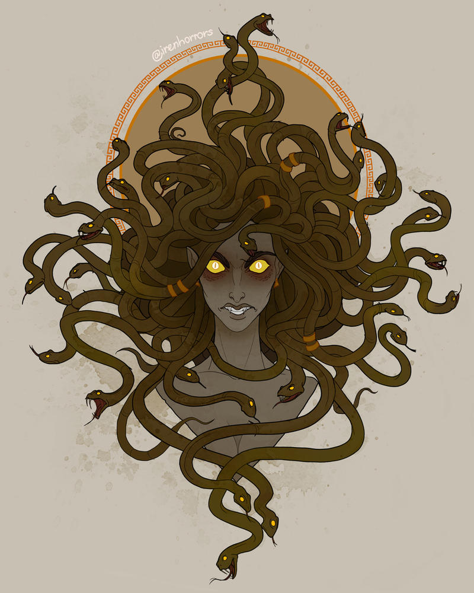  What are the features of a character description?  - Appearance  - Actions – how the character moves  - Personality  - Speech – how the character talks  Create a word bank of adjectives, verbs and adverbs that could be used to describe it.
 | Maths | Divide 2-digits by 1-digit (1)  https://whiterosemaths.com/homelearning?year=year-3  Make sure you select Year 3. Then choose the video labelled: Divide 2-digits by 1-digit (1)
 | Foundation Subject | Topic  Create a fact file using all the information you already have on Ancient Egypt.
 | PE link | Virtual warm up  https://www.youtube.com/watch?v=ctZmWxYHWZk
Thursday | Subject:
 | Literacy | Myths and Legends – write a character description  Using your plan from yesterday, write your character description of Medusa.
 | Maths | Divide 2-digits by 1-digit (2)  https://whiterosemaths.com/homelearning?year=year-3  Make sure you select Year 3. Then choose the video labelled: Divide 2-digits by 1-digit (2)
 | Foundation subject | Science – What is the difference between night and day?  https://classroom.thenational.academy/lessons/what-is-the-difference-between-night-and-day-60wp2c
 | PE link | Yoga PE  https://www.youtube.com/watch?v=47Se2HWSv9k
Friday | Subject:
 | Literacy | Myths and Legends – up-level and continue a setting description  Look at the picture of the Minotaur’s labyrinth.  What can you see?  What can you hear?  What can you smell?  What can you touch?  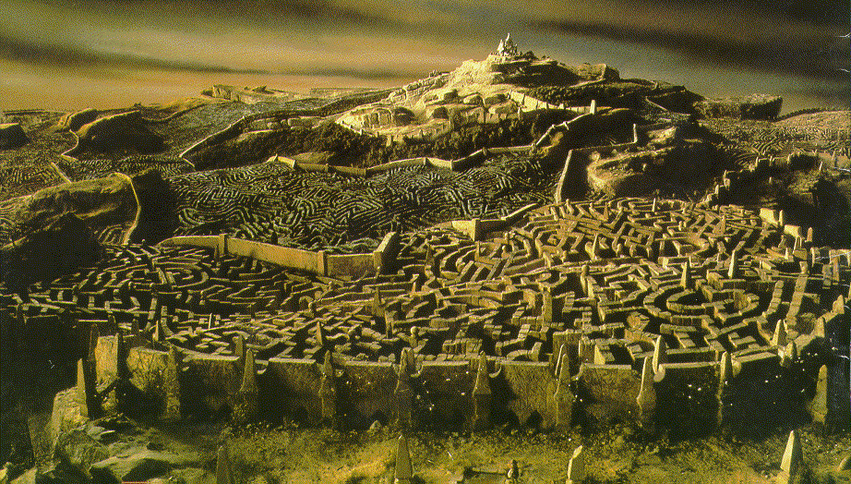  Read through this description. Once you have finished editing and up-levelling continuing writing your own sentences.  Remember to do the following:  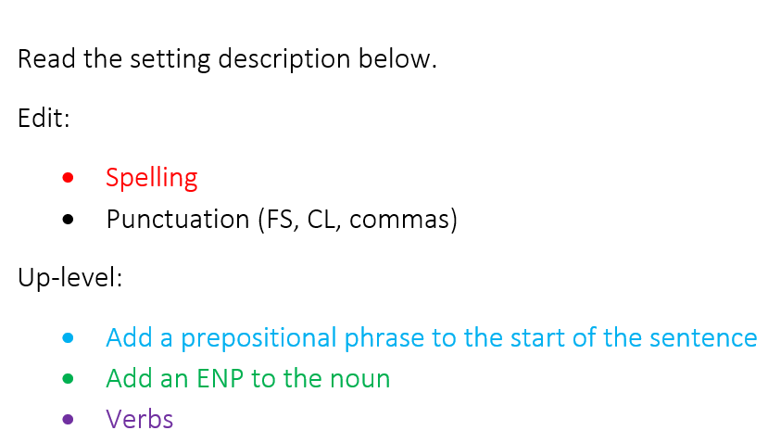  The doors of the maze slammed shut behind thesus and he stepped into the maze. thesus walked carefully threw the passages There were the bones of the minotour’s victims. His hands were shakin as he ran them along the wall to find his way around the maze. he heard a growl.
 | Maths | Divide 100 into 2,4,5 and 10 equal parts  https://whiterosemaths.com/homelearning?year=year-3  Make sure you select Year 3. Then choose the video labelled: Divide 100 into 2,4,5 and 10 equal parts
 | Foundation subject | RE  Sharing is an important aspect of Islam and Muslims believe sharing to be an important part of their faith.  Why might Muslims try to make the world better by trying to lessen or stop poverty and injustice. Is it just Muslims that want to make the world better?  What does it mean to ‘be charitable’?  What sorts of things can people give? Why should they? Why should we?  Read through what the Qur’an teaches:  - ‘And be steadfast in prayer and regular in charity. And whatever good you send out before you, you shall find it with Allah: for Allah sees all that you do.' (Qur'an 2:110)  - 'So establish regular prayer and give regular charity; and obey the Apostle; that you may receive mercy.' (Qur'an 24:56)  - 'For those who give in charity, men and women, and loan to Allah a beautiful loan, it shall be increased manifold (to their credit) and they shall have (besides) a liberal reward.' (Qur'an 57:18)  You will need to sort the statements out. Some are true and some are false.
 | PE link | Avengers kids workout  https://www.youtube.com/watch?v=IEpCqW9JqgY

