Remote Learning Year: 2 Week beginning: 20.06.22

Email address to return completed work to:
2A remotelearning2a@cantcros.bham.sch.uk
2E remotelearning2e@cantcros.bham.sch.uk

Day 1: | Subject:
 | Literacy | Create a role on the wall for Paddington Bear. Write adjectives to describe his appearance and personality.
 | Maths | Subtraction
 | Foundation subject | Science
 | PE link | PE
Day 2: | Subject:
 | Literacy | Write a character description about Paddington Bear. Remember to describe the appearance and personality using ENPs.
 | Maths | Addition and Subtraction
 | Foundation subject | Geography
 | PE link | PE
Day 3: | Subject:
 | Literacy | Using your 5 senses, write some adjectives to describe what you can see, hear, smell, taste and touch.  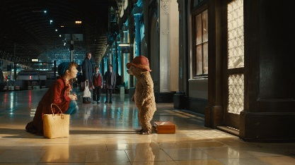
 | Maths | Multiplication
 | Foundation subject | Art
 | PE link | Tallulah the Owlet | A Cosmic Kids Yoga Adventure!
Day 4: | Subject:
 | Literacy | Using your adjectives from yesterday, write a setting description about Paddington Train Station.  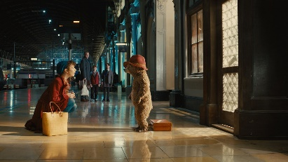
 | Maths | Division
 | Foundation subject | Music
 | PE Link | P.E with Joe | Monday 23rd March 2020
Day 5: | Subject:
 | Literacy | Plan the beginning of your adventure story based on Paddington Bear.  Think about the characters and settings. Write ENPs to describe them.
 | Maths | Word Problems
 | Foundation subject | PSHE
 | PE link | Yoga For Kids | Cosmic Kids

