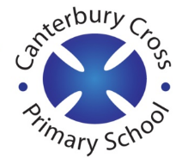
Remote Learning Year: 3 Week beginning: 24.01.22

Email address to return completed work to:
3S remotelearning3S@cantcros.bham.sch.uk
3G remotelearning3G@cantcros.bham.sch.uk

Monday | Subject:
 | Literacy | To orally rehearse a section of narrative  https://classroom.thenational.academy/lessons/to-orally-rehearse-a-section-of-narrative-6dgkge
 | Maths | Measuring length to the nearest cm or mm  https://classroom.thenational.academy/lessons/measuring-lengths-to-the-nearest-cm-or-mm-65k64d
 | Foundation Subject | RE  What do these signs mean?  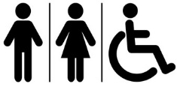  Signs have a specific/direct meaning.  What do these symbols mean?  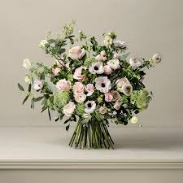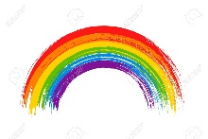  A symbol is a thing that represents or stands for another.  Watch this video:  https://www.truetube.co.uk/film/formation-khalsa  Pause after the Guru returns the first time with blood on the sword.  - How would you be feeling?  Play video up until the Guru returns to the crows after the fifth man has gone in.  - Why do you think the men kept going up to the Guru?  - What do you think it means to be part of the Khalsa?  https://www.youtube.com/watch?v=FRpygummmh8  Watch from 1:54  Task  Come up with your own symbol and explain what it means.
 | PE link | Joe Wicks active 8 minute workout  https://www.youtube.com/watch?v=uqLNxJe4L2I
Tuesday | Subject:
 | Literacy | To investigate prefixes  https://classroom.thenational.academy/lessons/to-investigate-prefixes-6hgpae
 | Maths | Measuring length and drawing lines of a given length in mixed units  https://classroom.thenational.academy/lessons/measuring-length-and-drawing-lines-of-a-given-length-in-mixed-units-69j3ed
 | Foundation Subject | Science – How does a compass work?  https://classroom.thenational.academy/lessons/how-does-a-compass-work-6rr30d
 | PE link | Joe Wicks active 8 minute workout  https://www.youtube.com/watch?v=uqLNxJe4L2I
Wednesday
 | Literacy | To revise our understanding of simple compound and complex sentences  https://classroom.thenational.academy/lessons/to-revise-our-understanding-of-simple-compound-and-complex-sentences-74t64d
 | Maths | Making appropriate estimates of length by comparing  https://classroom.thenational.academy/lessons/making-appropriate-estimates-of-length-by-comparing-69hk8c
 | Foundation Subject | Topic – Who rules Ancient Egypt?  https://classroom.thenational.academy/lessons/who-ruled-ancient-egypt-c8w32t
 | PE link | Joe Wicks active 8 minute workout  https://www.youtube.com/watch?v=uqLNxJe4L2I
Thursday | Subject:
 | Literacy | To generate ideas for writing  https://classroom.thenational.academy/lessons/to-generate-ideas-for-writing-64ukec
 | Maths | Length and measurement application  https://classroom.thenational.academy/lessons/length-and-measurement-application-ccr68e
 | Foundation subject | Science – How can we tell if a material is magnetic or not?  https://classroom.thenational.academy/lessons/how-can-we-tell-if-a-material-is-magnetic-or-not-cmtpar
 | PE link | Joe Wicks active 8 minute workout  https://www.youtube.com/watch?v=EDC-plCTBbc
Friday | Subject:
 | Literacy | To develop a rich understanding of words associated with clever or sly traits (part 1)  https://classroom.thenational.academy/lessons/to-develop-a-rich-understanding-of-words-associated-with-clever-or-sly-traits-part-1-6cr6ad
 | Maths | Measuring and comparing length in mixed units (cm and mm)  https://classroom.thenational.academy/lessons/measuring-and-comparing-length-in-mixed-units-cm-and-mm-64r64c
 | Foundation subject | Music – understanding pulse and rhythm  https://classroom.thenational.academy/lessons/understanding-pulse-and-rhythm-c8up2t
 | PE link | Joe Wicks Active 8 minute Workout  https://www.youtube.com/watch?v=E5cmJpSFZB8

