Remote Learning Year: 6 Week beginning: 13.12.21

Email address to return completed work to:
6A remotelearning6a@cantcros.bham.sch.uk
6D remotelearning6d@cantcros.bham.sch.uk

Day 1: | Subject:
 | Literacy | SPAG revision.  Click and enlarge the image to complete the task.  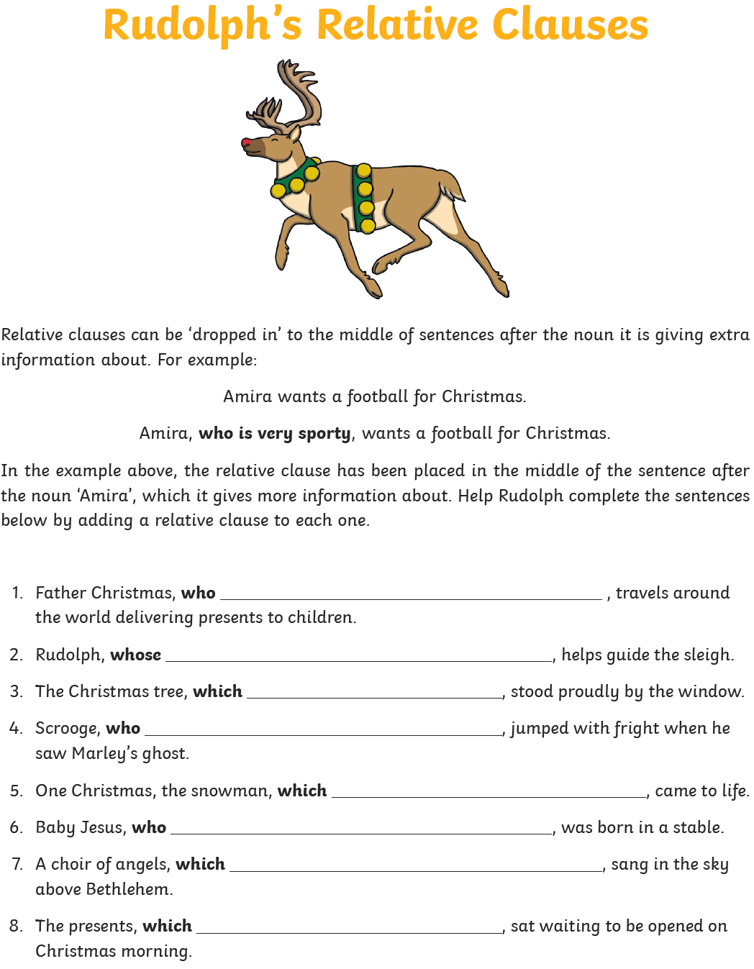
 | Maths | Click and enlarge the image to complete the task.  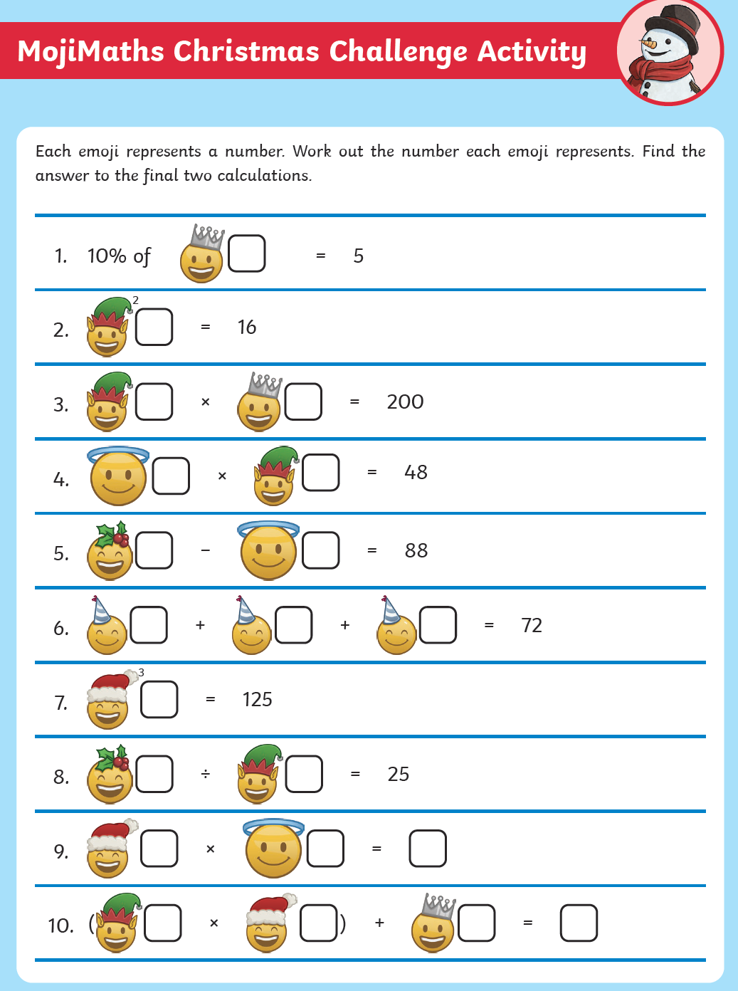
 | Foundation subject  Science | What is light? Do the quiz.  https://www.bbc.co.uk/bitesize/topics/zbssgk7/articles/z2s4xfr
 | PE link | 5 minute move 1  https://www.youtube.com/watch?v=d3LPrhI0v-w
Day 2: | Subject:
 | Literacy | SPAG revision.  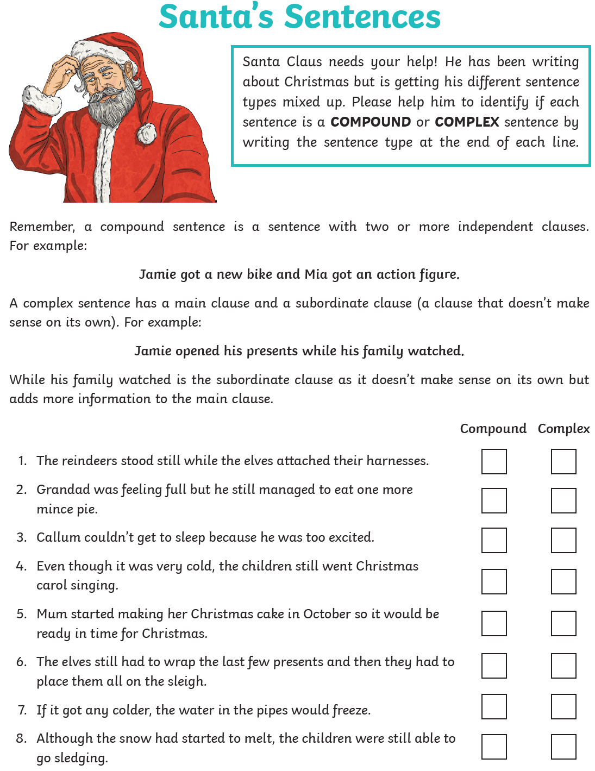
 | Maths | 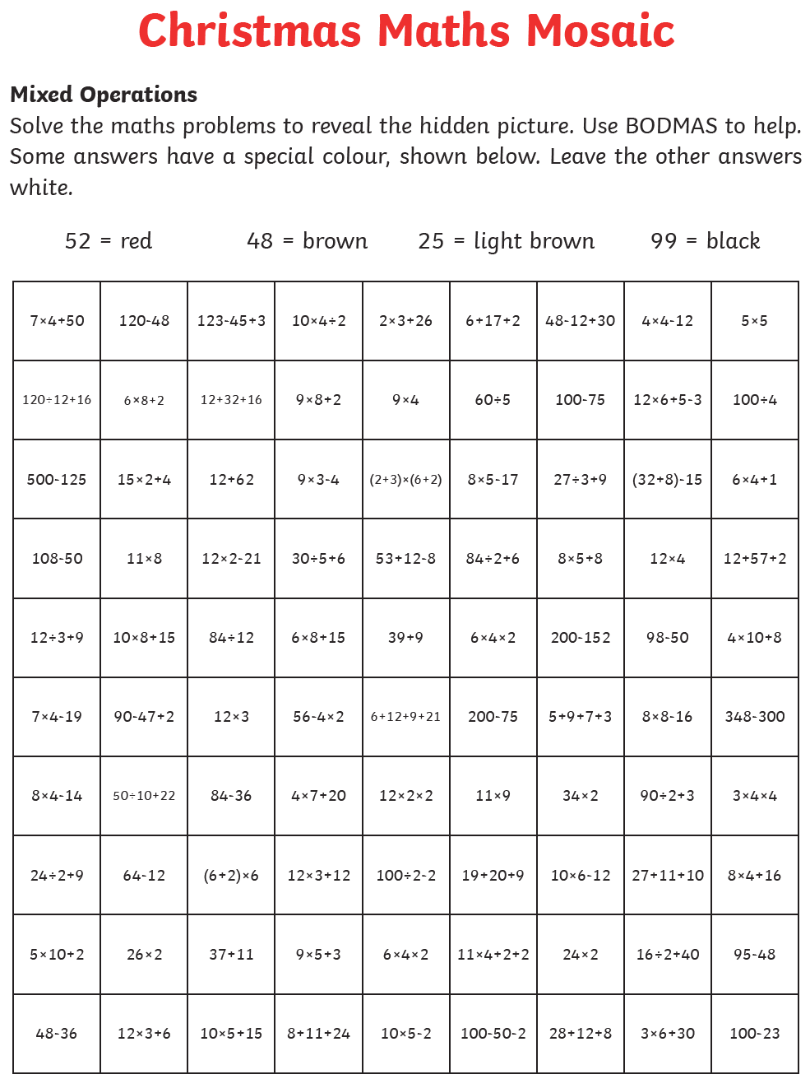
 | Foundation subject  RE | What is Buddhism? Take the quiz and create a poster  https://www.bbc.co.uk/bitesize/topics/zh4mrj6/articles/zdbvjhv
 | PE link | 5 minute move 2  https://www.youtube.com/c/TheBodyCoachTV
Day 3: | Subject:
 | Literacy | SPAG revision.  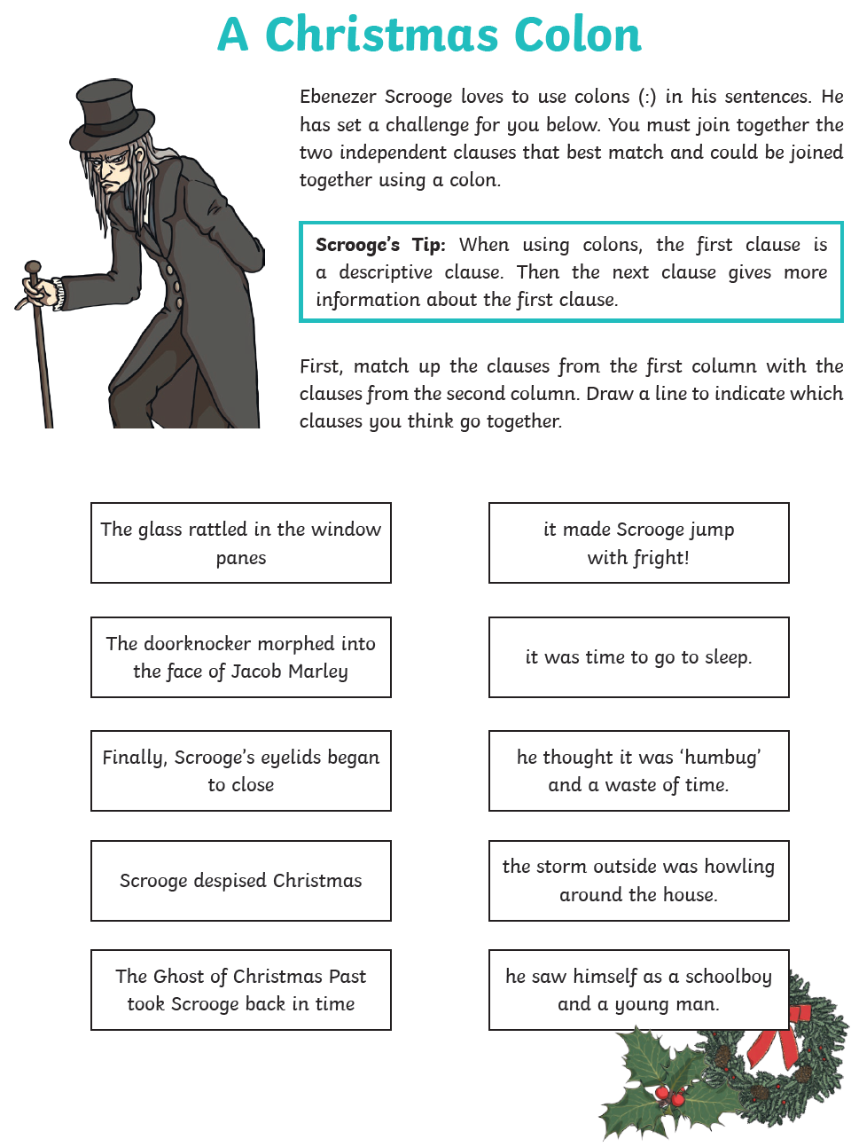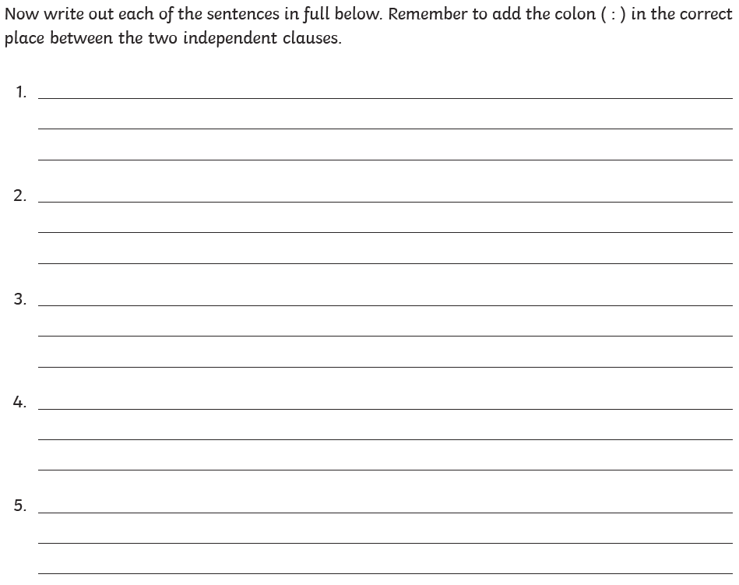
 | Maths | 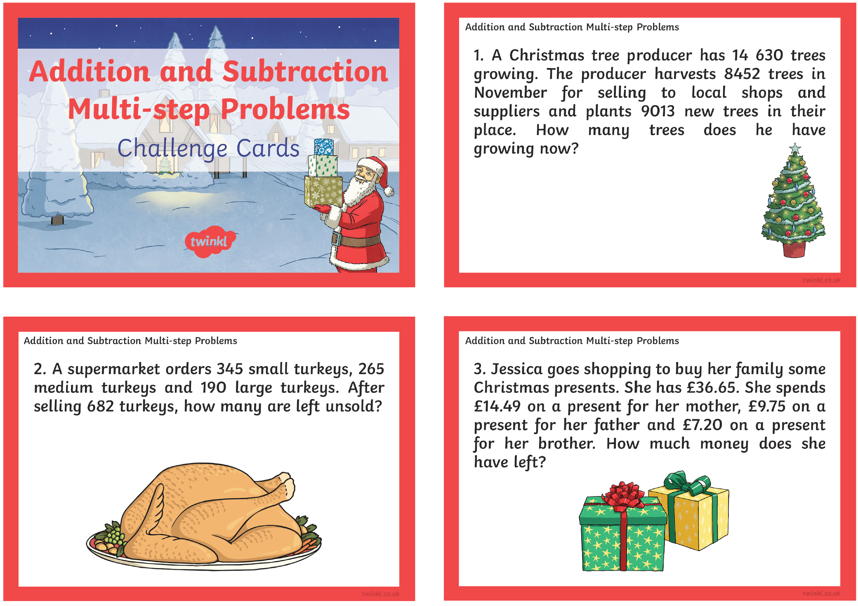
 | Foundation subject  Art | How To Draw a Snow Globe  https://www.youtube.com/watch?v=FeYJAGqmNs4
 | PE link | Active 8 Minute Workout 1  https://www.youtube.com/watch?v=YIB2SJnBHBQ
Day 4: | Subject:
 | Literacy | Comprehension.  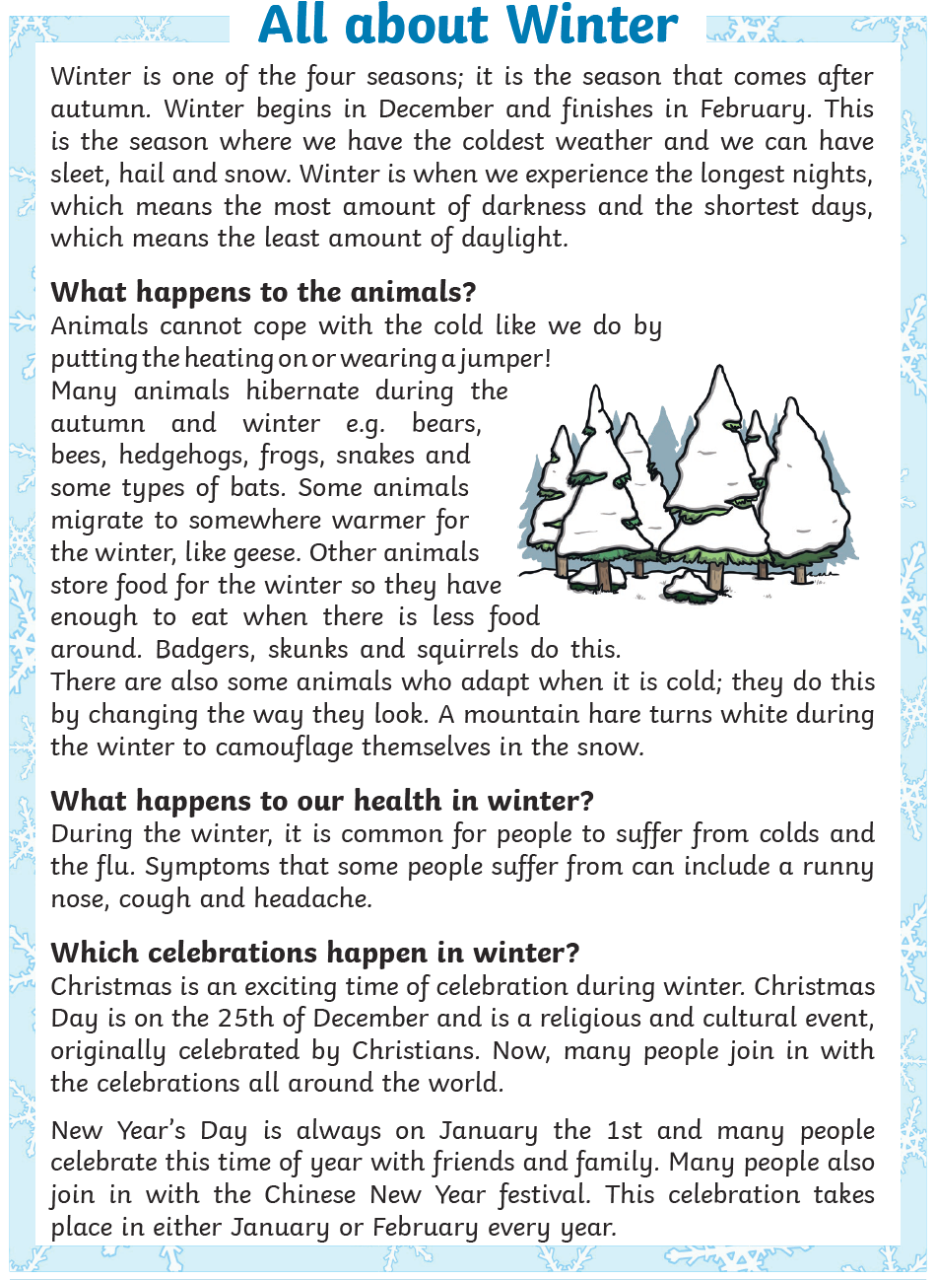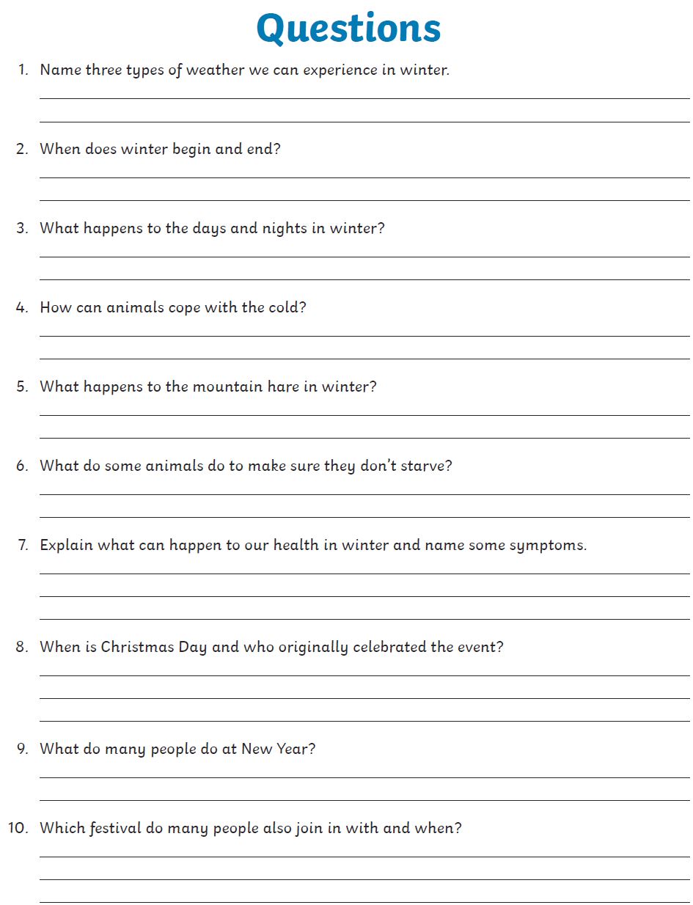
 | Maths | 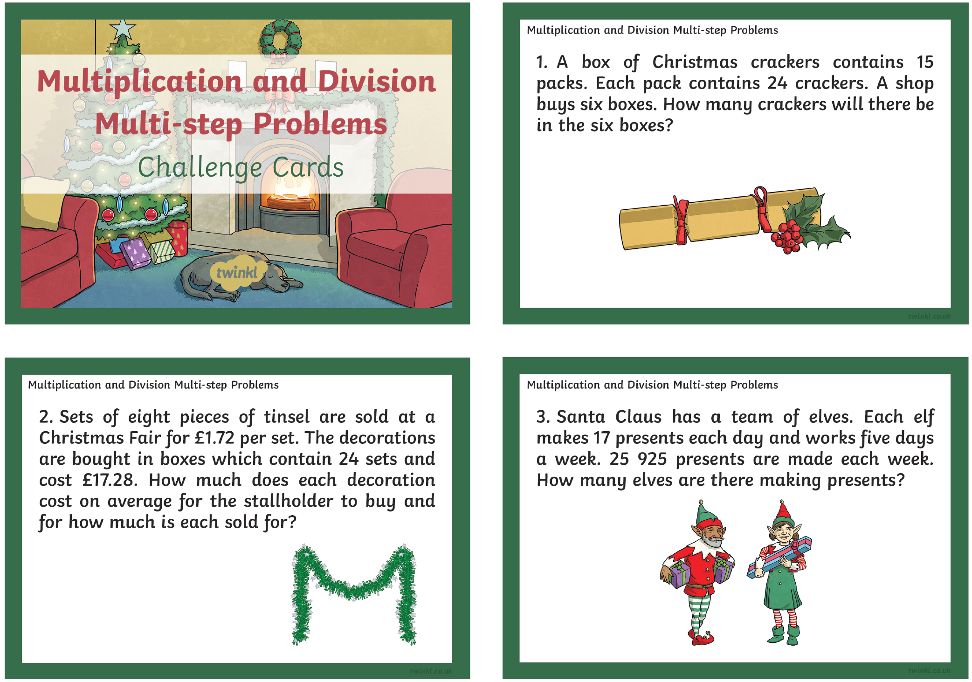
 | Foundation subject  History | Watch the video https://www.youtube.com/watch?v=Xh_Lk7kDrUI  Explain industrial revolution in your own words.
 | PE link | Active 8 Minute Workout 2  https://www.youtube.com/watch?v=EDC-plCTBbc
Day 5: | Subject:
 | Literacy | Comprehension.  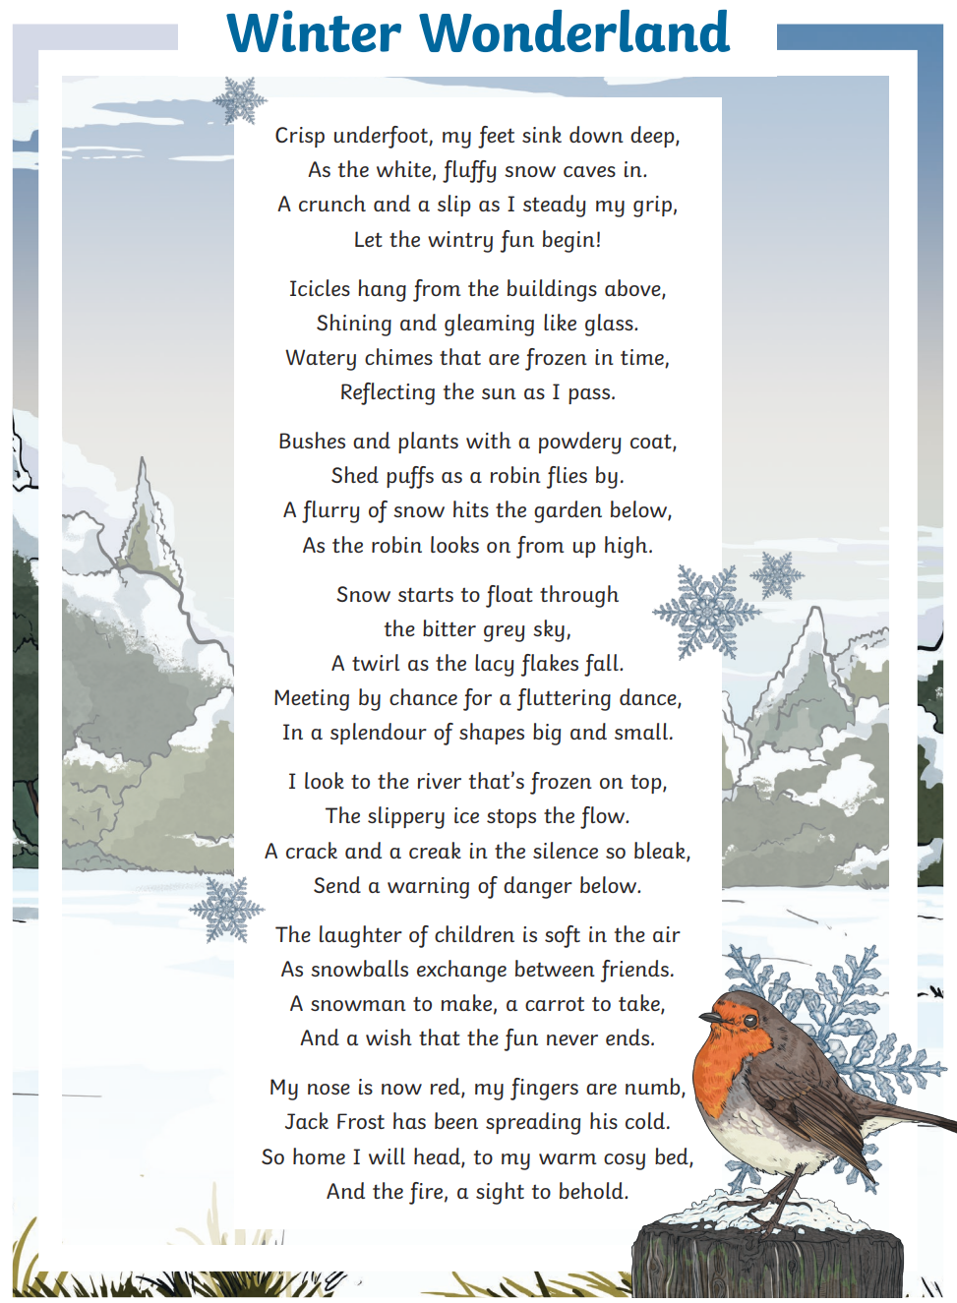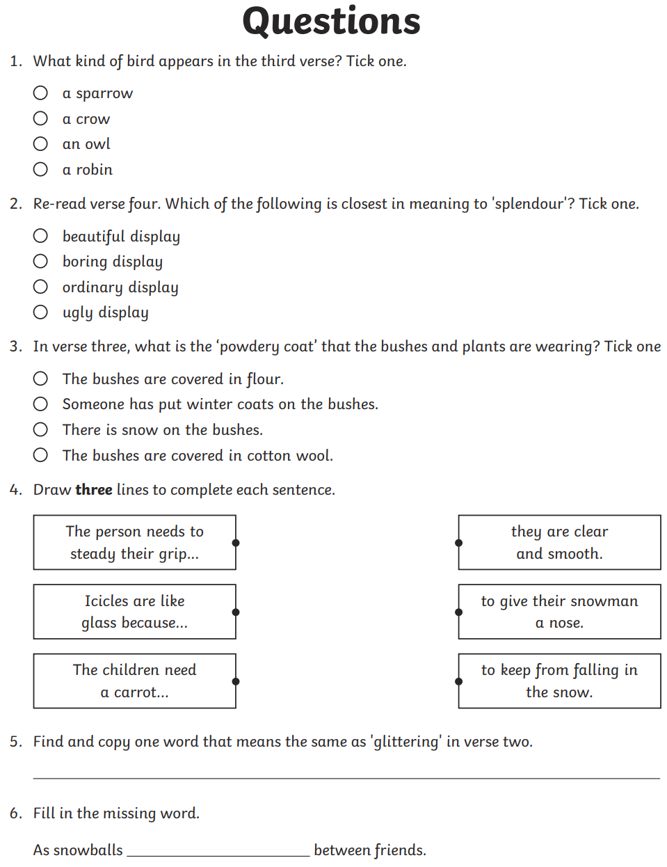
 | Maths | 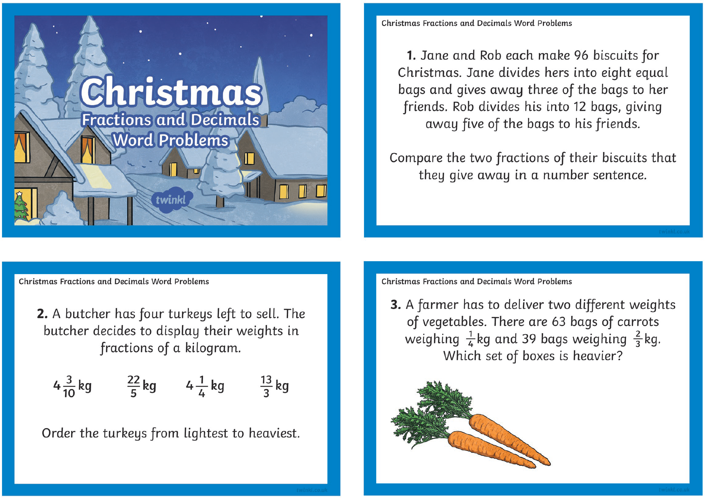
 | Foundation subject  Art | How to Draw a Winter Village  https://www.youtube.com/watch?v=azKix_qH2Qk
 | PE link | Energising workout  https://www.youtube.com/watch?v=5MBEyQIlrfo&list=PLyCLoPd4VxBuxu3sLztrvWFehzv-LnR2c&index=7

