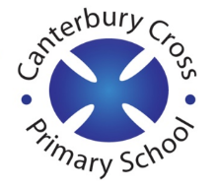
Remote Learning Year: 6 Week beginning: 28.02.22

Email address to return completed work to:
6A remotelearning6a@cantcros.bham.sch.uk
6D remotelearning6d@cantcros.bham.sch.uk

Day 1: | Subject:
 |  | Teacher training
Day 2: | Subject:
 | Literacy | Click and enlarge to complete task.  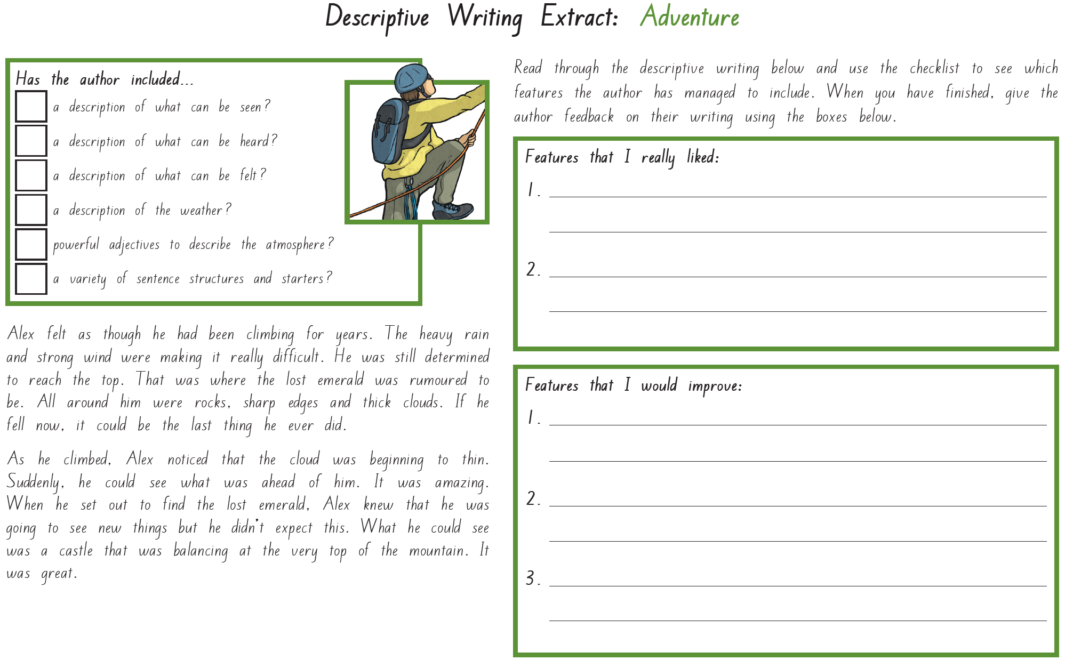
 | Maths | Click and enlarge to complete task.  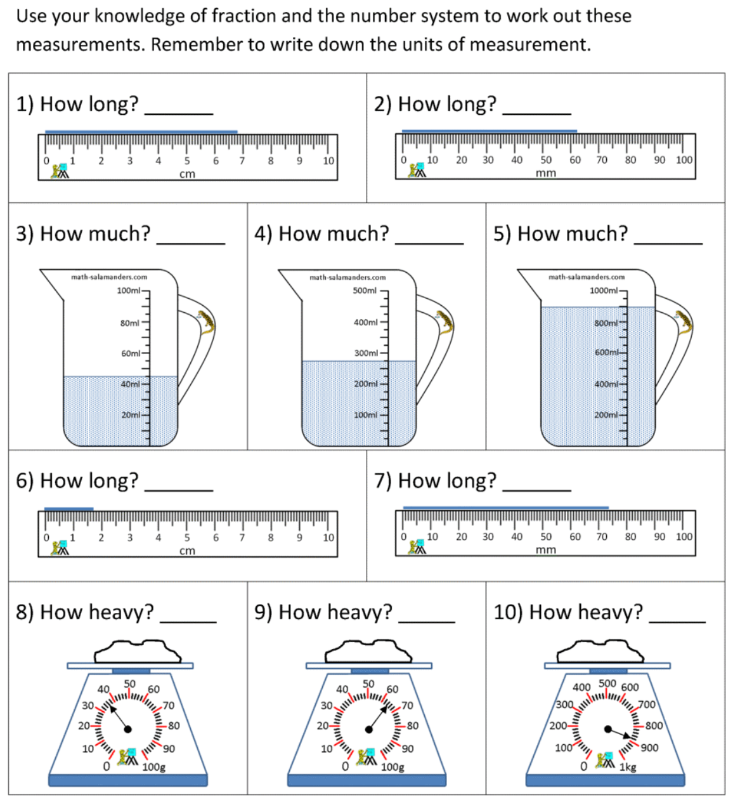
 | Foundation subject  PSHE | Employment  https://classroom.thenational.academy/lessons/employment-71h3ct
 | PE link | Fitness circuits  https://www.youtube.com/watch?v=pImrFWw0Fxw&list=RDCMUCliBigoW1uxxMGtVIGTGwMw&start_radio=1&rv=pImrFWw0Fxw&t=167
Day 3: | Subject:
 | Literacy | Click and enlarge to complete task.  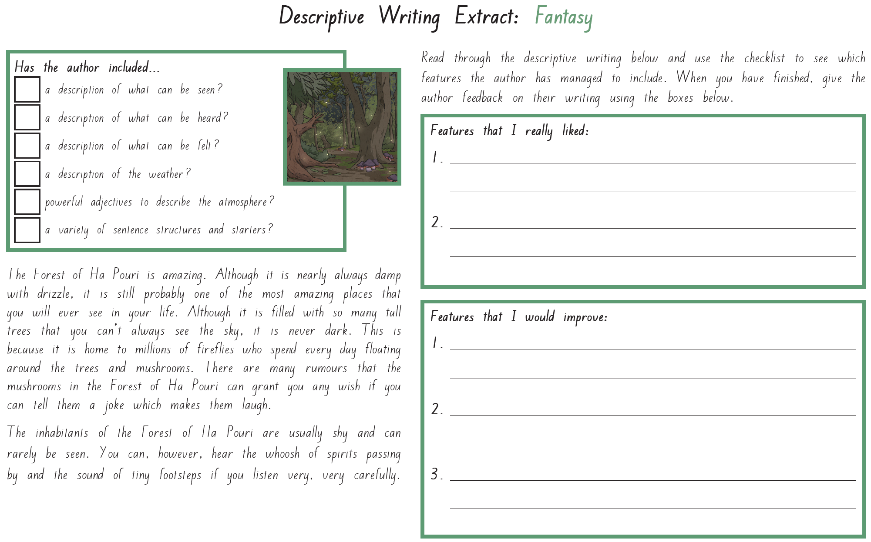
 | Maths | Click and enlarge to complete task.  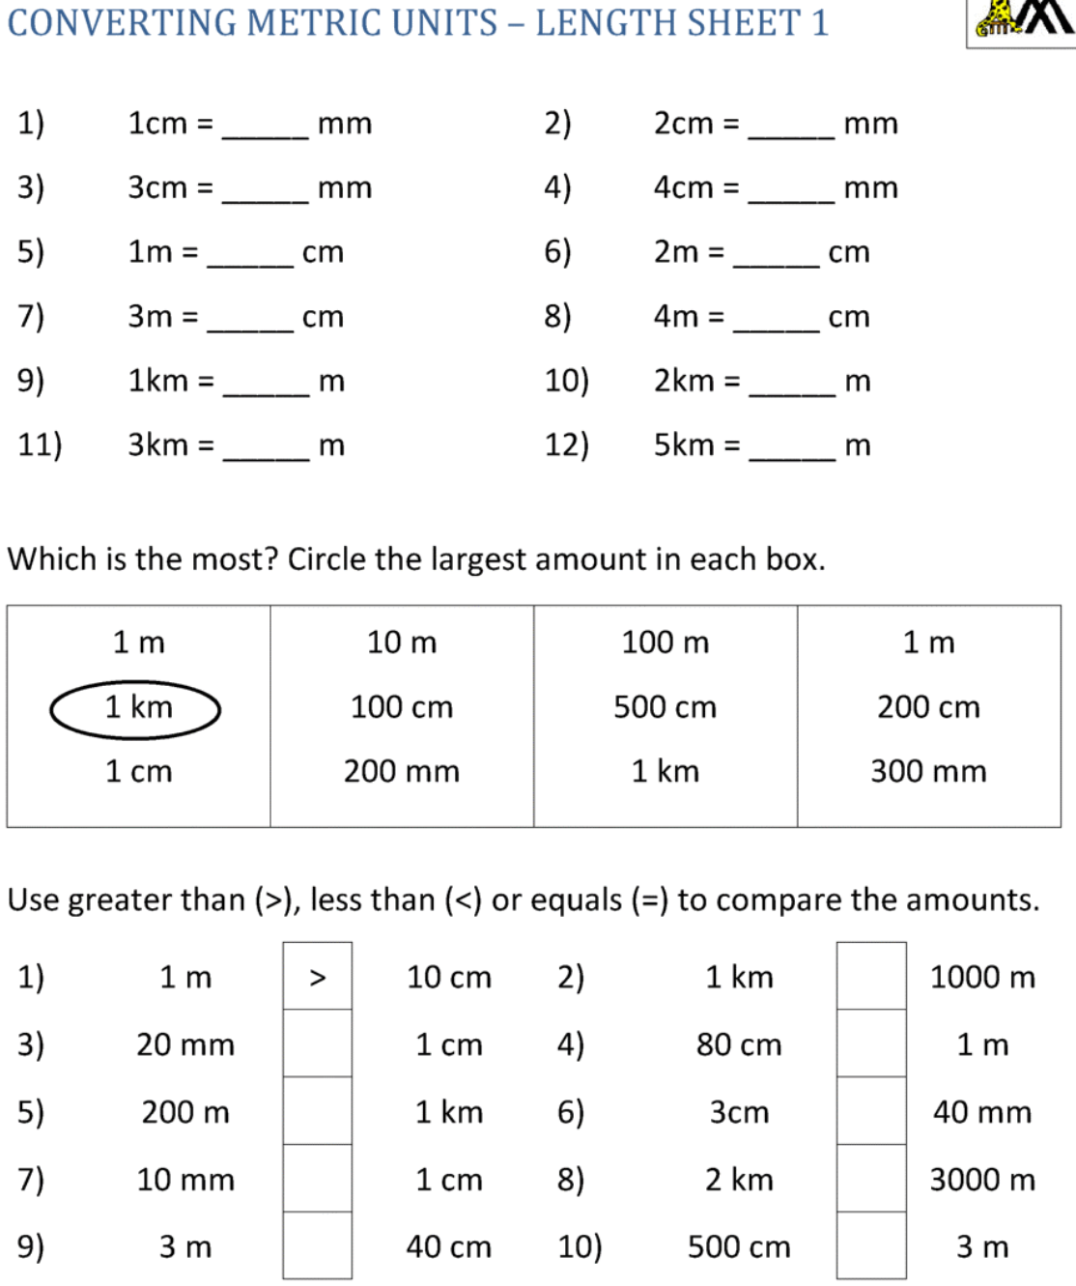
 | Foundation subject  Science | How do scientific ideas change?  https://classroom.thenational.academy/lessons/how-do-scientific-ideas-change-crv6cc
 | PE link | Yoga freeze dance  https://www.youtube.com/watch?v=EcnQNWBXE5s
Day 4: | Subject:
 | Literacy | Click and enlarge to complete task.  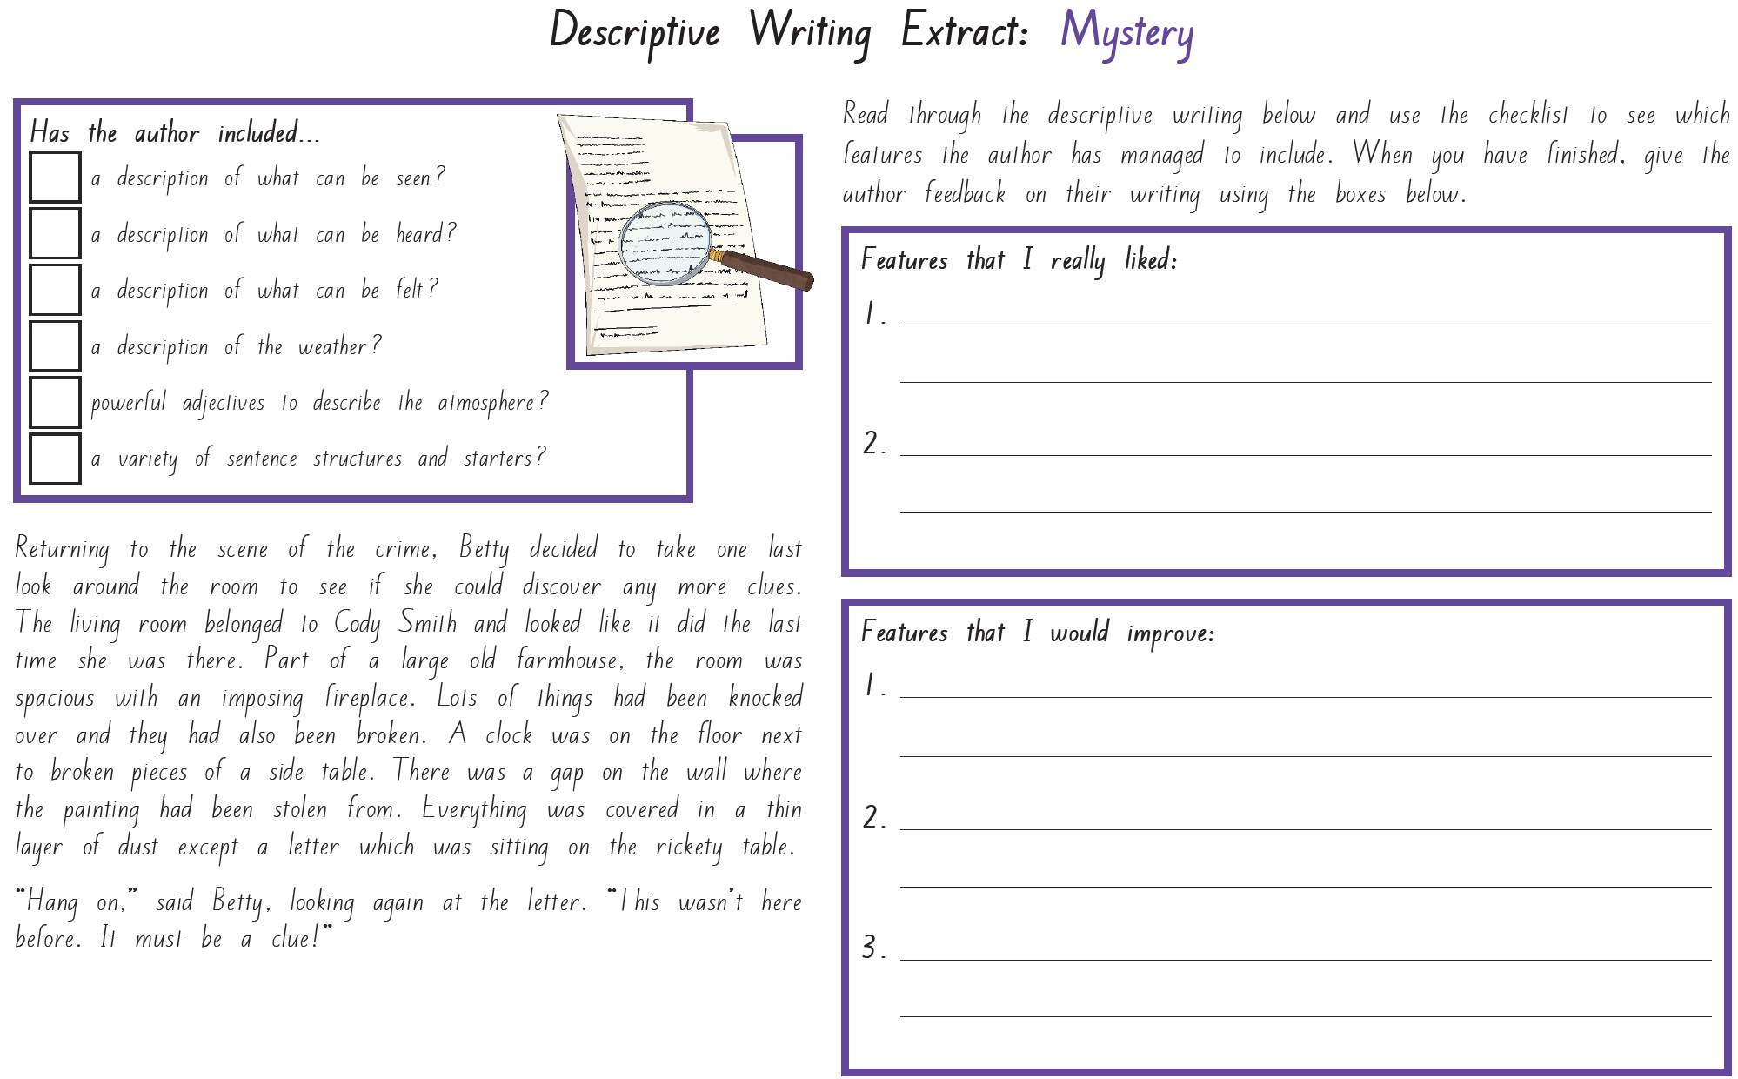
 | Maths | Click and enlarge to complete task.  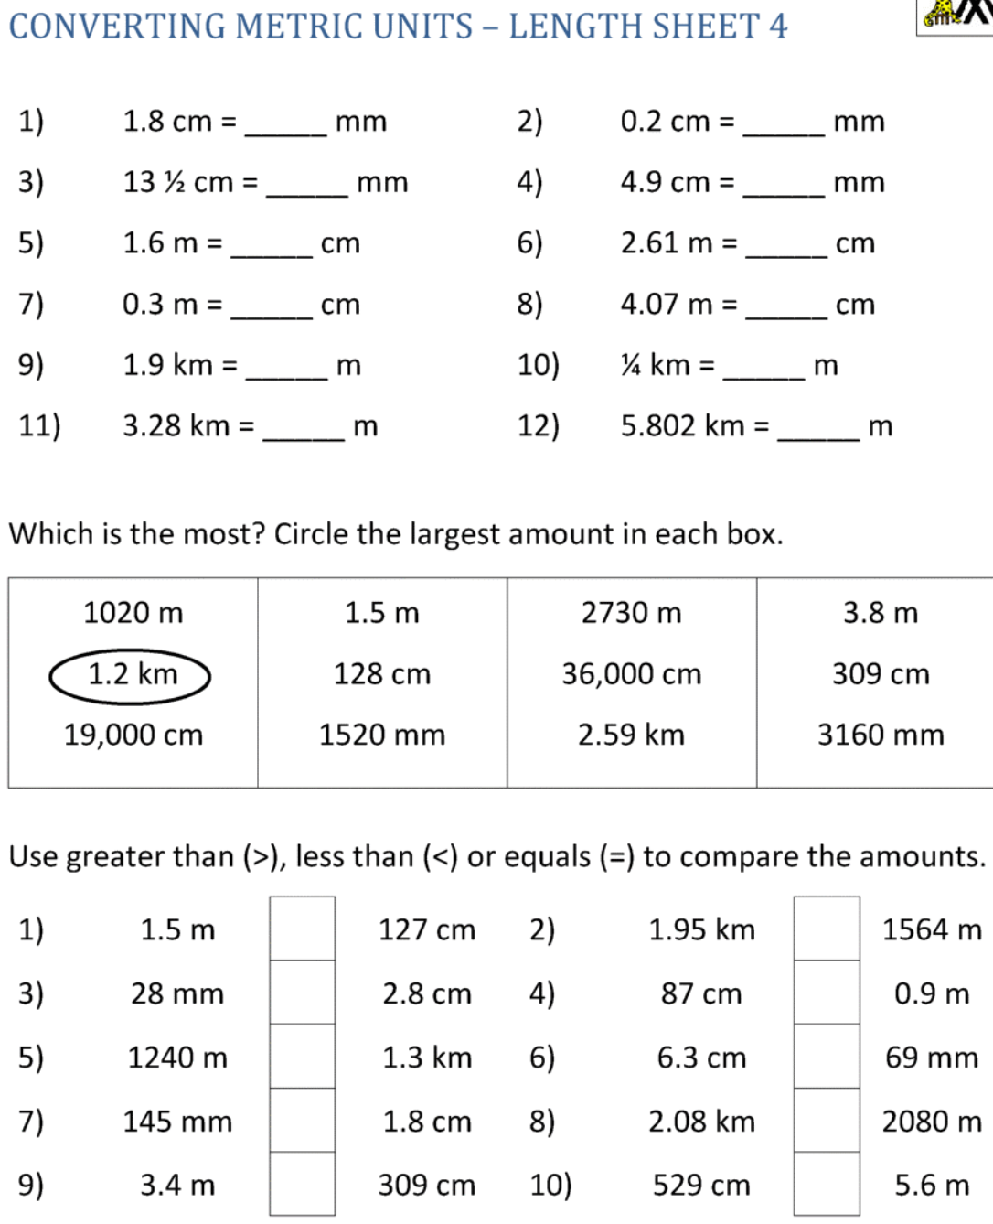
 | Foundation subject  Art | Op-Art Pop-Art  https://www.youtube.com/watch?v=NZfj81PEn9o
 | PE link | Just Dance  https://www.youtube.com/watch?v=qtMVAA0EfNE
Day 5: | Subject:
 | Literacy | Click and enlarge to complete task.  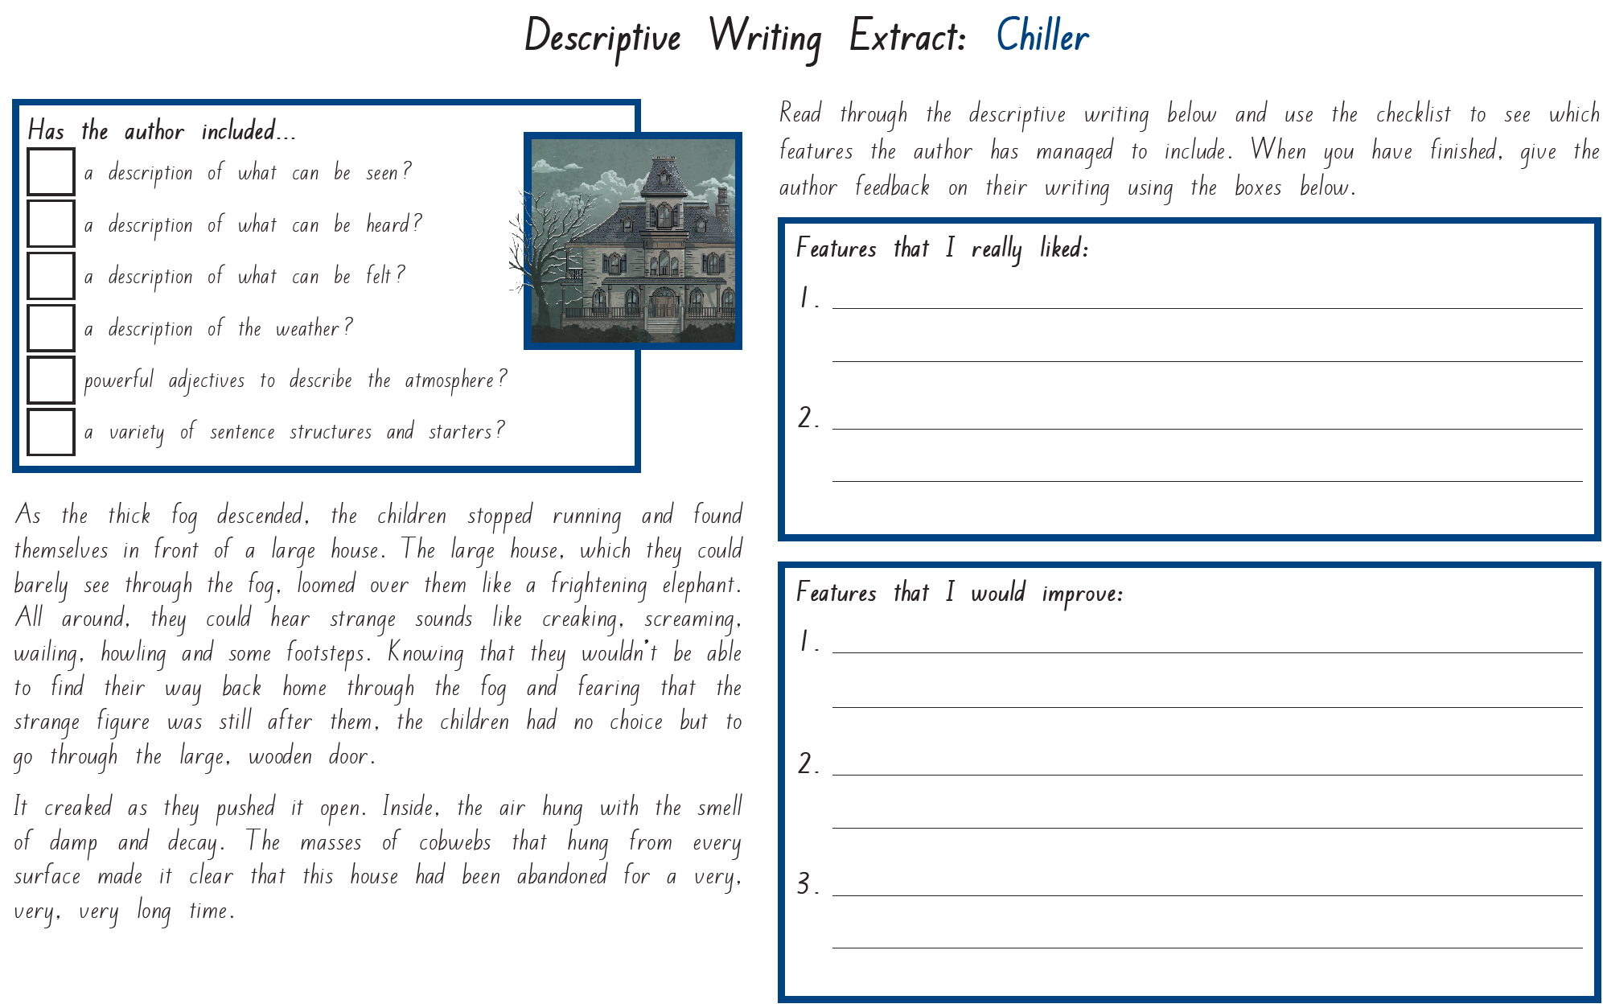
 | Maths | Arithmetic  https://myminimaths.co.uk/arithmetic-16-practice-questions/
 | Foundation subject  Art | How to Draw a 3D Monster  https://www.youtube.com/watch?v=zn2VYPsovZM&list=RDCMUChJX37Qpc8U-xQDmm4DcGyA&index=3
 | PE link | Red Light, Green Light dance party  https://www.youtube.com/watch?v=2tRCBPk4NMQ

