Remote Learning Year: 3 Week beginning: 02.05.22

Email address to return completed work to:
3S remotelearning3S@cantcros.bham.sch.uk
3G remotelearning3G@cantcros.bham.sch.uk

Monday | Subject:
 | Bank Holiday
Tuesday | Subject:
 | Literacy | Compare a nonsense and narrative poem  Read through the nonsense poem ‘Ning Nang Nong’ on the internet.  Read through the narrative poem ‘Benjamin Bear’ on the internet.  How are nonsense and narrative poetry similar?  How are they different?  Which do you prefer? Why?
 | Maths | Miss Sprott’s Group – Exploring units of measured time  https://classroom.thenational.academy/lessons/exploring-units-of-measured-time-cngp4c  Miss Gibbs’ Group – Count money (pence)  https://vimeo.com/497343674
 | Foundation Subject | Topic – Which animals lived in prehistoric Britain  https://classroom.thenational.academy/lessons/which-animals-lived-in-prehistoric-britain-cgw6cd
 | PE link | Street dance house masterclass  https://www.youtube.com/watch?v=agezOTZ1RZ8
Wednesday
 | Literacy | Plan a nonsense poem  Read the poem called ‘To B or not to B’ by Kenn Nesbitt.  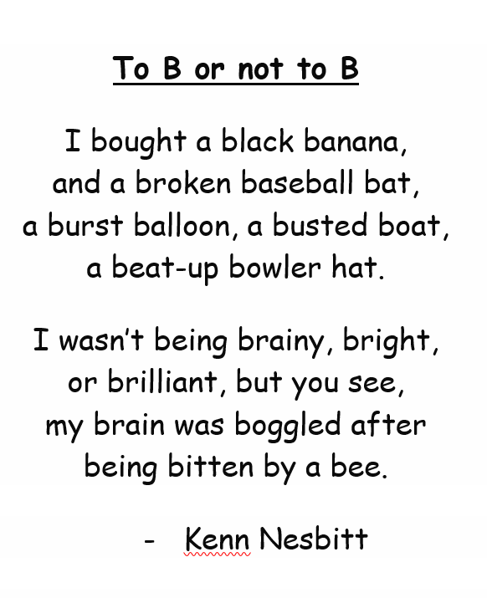  What do you notice about this poem?  You are going to create your own version of the poem using a different letter of your choosing.  Look at my example using the letter C  Complete the table of verbs, adjectives and nouns all beginning with your letter.  This will be used as part of their poem, and that the alliteration is important to keep it in the style of Kenn Nesbitt.  Verbs Adjectives Nouns  Catch Click Chat Chew cook Calm Cool Cold Careful cheerful Crayon Card Cat Candy car  Keep this as you will need it to write your poem tomorrow.
 | Maths | Miss Sprott’s Group – Measuring time in seconds  https://classroom.thenational.academy/lessons/measuring-time-in-seconds-74rk2t  Miss Gibbs’ Group – Count money (pounds)  https://vimeo.com/497344241
 | Foundation Subject | PSHE – I have rights  https://classroom.thenational.academy/lessons/i-have-rights-64v3et
 | PE link | Yoga for the classroom  https://www.youtube.com/watch?v=Td6zFtZPkJ4
Thursday | Subject: | Election day
 | Literacy | Write a nonsense poem  Using your plan from yesterday. Have a go at writing your own nonsense poem. Look at my example below:  I caught a cheerful chair  and a cuddly car  a chewy cherry, a cheerful car,  a cool cookie jar.  Notice how lines two and four rhyme. Your poem needs to as well! Don’t forget to use your plan and keep as much alliteration as possible!
 | Maths | First log into TTRS and play for 10 minutes.  Then complete the following video and use the information to find your worksheet on twinkl.  Miss Sprott’s Group – Calculating and comparing intervals of time  https://classroom.thenational.academy/lessons/calculating-and-comparing-intervals-of-time-6gw3jc  Complete the sheet labelled:  Tell and Write the Time on Twinkl  Miss Gibbs’ Group – Count pounds and pence  https://vimeo.com/497345587  Complete the sheet labelled:  British Money Comparison Using Pound Coins and Notes on Twinkl.  http://twinkl.co.uk/go  Twinkl code: EG1269
 | Foundation subject | Science – What are the parts and functions of a plant  https://classroom.thenational.academy/lessons/what-are-the-parts-and-functions-of-a-plant-69gk8d  After watching the video, draw a picture and label the different parts of the plant and its function. Look at the example below:  Here are some keys words to help you:  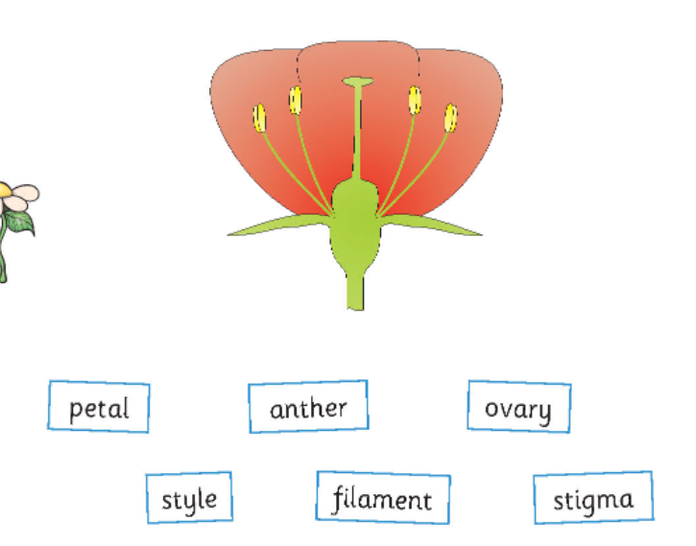 | RE – Understand the importance of the River Ganges to Hindus  http://www.ludlowprimaryschool.co.uk/media/25441/re-the-great-river-ganga-and-shiva.pdf  Read through this powerpoint about how Hindus believe the River Ganges came to be about.  Then, in your own words, rewrite the story of the River Ganges. It should be no more than 10 lines long.
Friday | Subject:
 | Literacy | Perform a nonsense poem  Using the poem you wrote yesterday, learn this poem off by heart and perform it to your friends and family.  TIPS!  Learn two lines at a time and then build it up to learning a stanza.  Add expression to make your reading more exciting.
 | Maths | Miss Sprott’s Group – Applying knowledge of time to solve problems  https://classroom.thenational.academy/lessons/applying-knowledge-of-time-to-solve-problems-ccuk4r  Miss Gibbs’ Group – Convert pounds and pence  https://vimeo.com/497942634
 | PE link | 5 alive kids workout – Joe Wicks  https://www.youtube.com/watch?v=h5PpLvMvW2s

