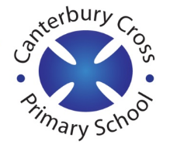
Remote Learning Year: 2 Week beginning: 23.05.22

Email address to return completed work to:
2A remotelearning2a@cantcros.bham.sch.uk
2E remotelearning2e@cantcros.bham.sch.uk

Day 1: | Subject:
 | Literacy | Recount
 | Maths | Position and Direction
 | Foundation subject | Geography
 | PE link | PE
Day 2: | Subject:
 | Literacy | Recount
 | Maths | Position and Direction
 | Foundation subject | Music
 | PE link | PE
Day 3: | Subject:
 | Literacy | Recount
 | Maths | Rotation
 | Foundation subject | Science
 | PE link | Tallulah the Owlet | A Cosmic Kids Yoga Adventure!
Day 4: | Subject:
 | Literacy | Recount
 | Maths | Rotation
 | Foundation subject | Draw your own portrait of the Queen.
 | PE Link | P.E with Joe | Monday 23rd March 2020
Day 5: | Subject:
 | Literacy | Recount
 | Maths | Rotation
 | Foundation subject | Create your own bunting for the Queen’s Jubilee.
 | PE link | Yoga For Kids | Cosmic Kids

