Remote Learning Year: 6 Week beginning: 25.04.22

Email address to return completed work to:
6A remotelearning6a@cantcros.bham.sch.uk
6D remotelearning6d@cantcros.bham.sch.uk

Day 1: | Subject:
 | Literacy | Grammar – word classes  https://classroom.thenational.academy/lessons/to-explore-word-class-68tkjc
 | Maths | Adjusting addends  https://classroom.thenational.academy/lessons/adjusting-addends-c5gpct
 | Foundation subject | Art – landscape  https://www.youtube.com/watch?v=DHOmyMYy3Ic
 | PE link | Dance and freeze  https://www.youtube.com/watch?v=OpwMOPpwdHM
Day 2: | Subject:
 | Literacy | Grammar – expanded noun phrases  https://classroom.thenational.academy/lessons/to-explore-expanded-noun-phrases-64r3ec
 | Maths | Same sum with larger numbers  https://classroom.thenational.academy/lessons/same-sum-with-larger-numbers-ccw68d
 | Foundation subject | PSHE  Sort these activities into those that help with a good night’s sleep and those that are not. Click and enlarge to access.  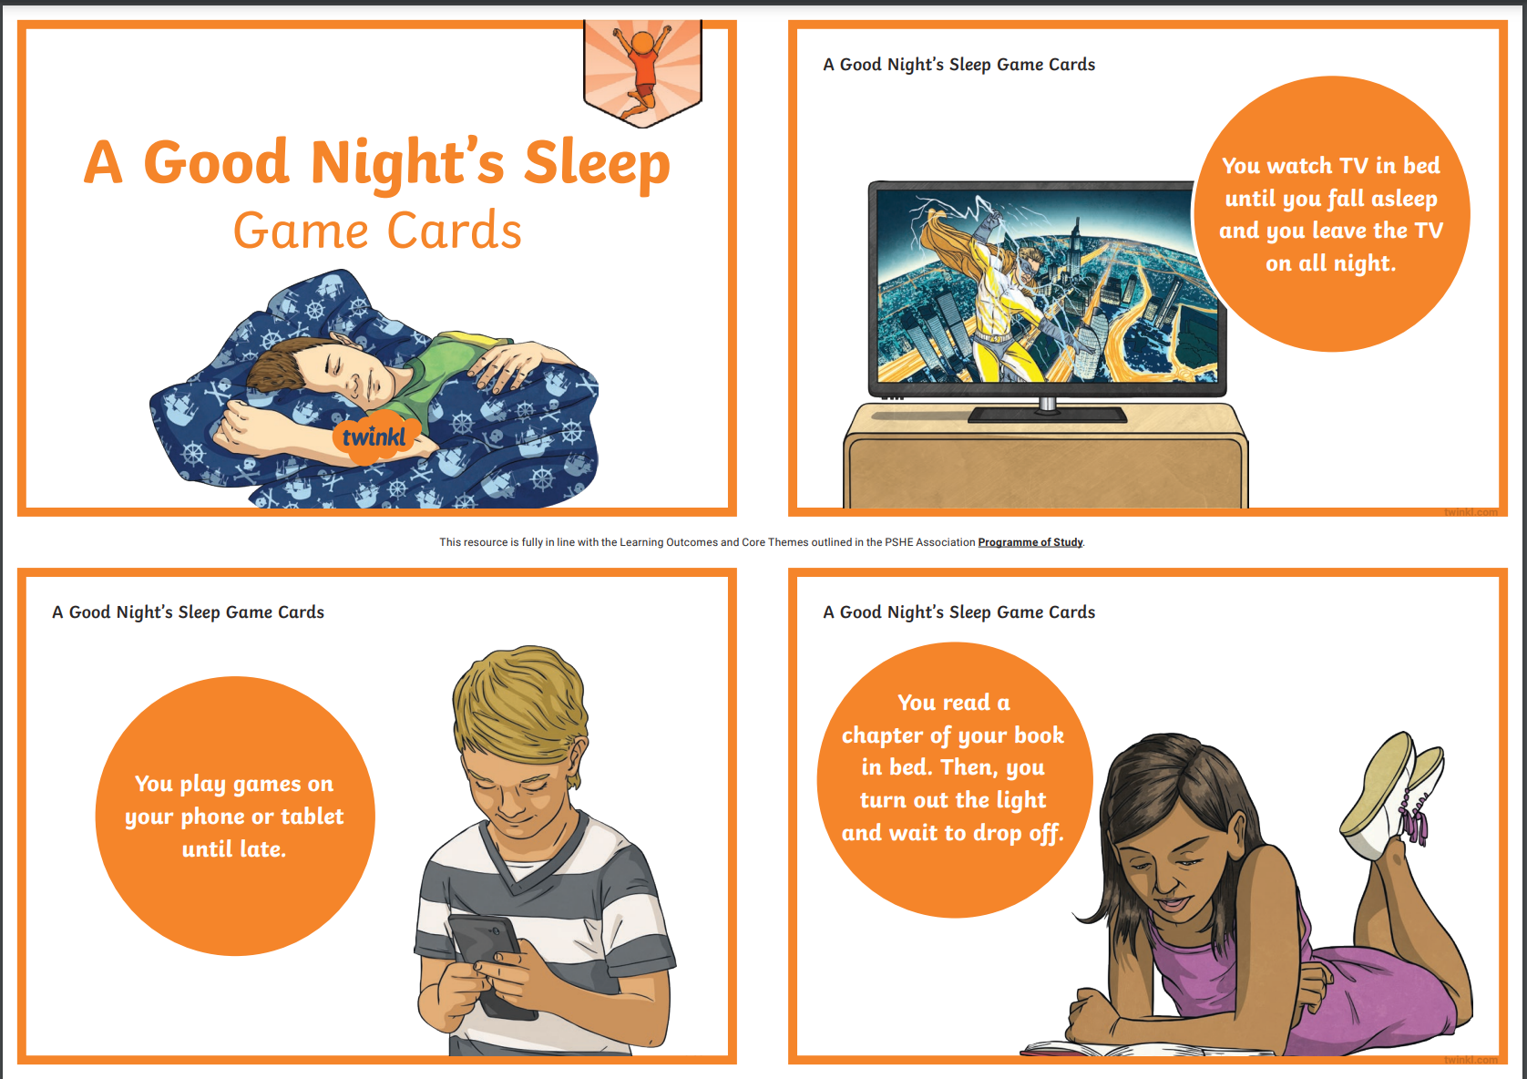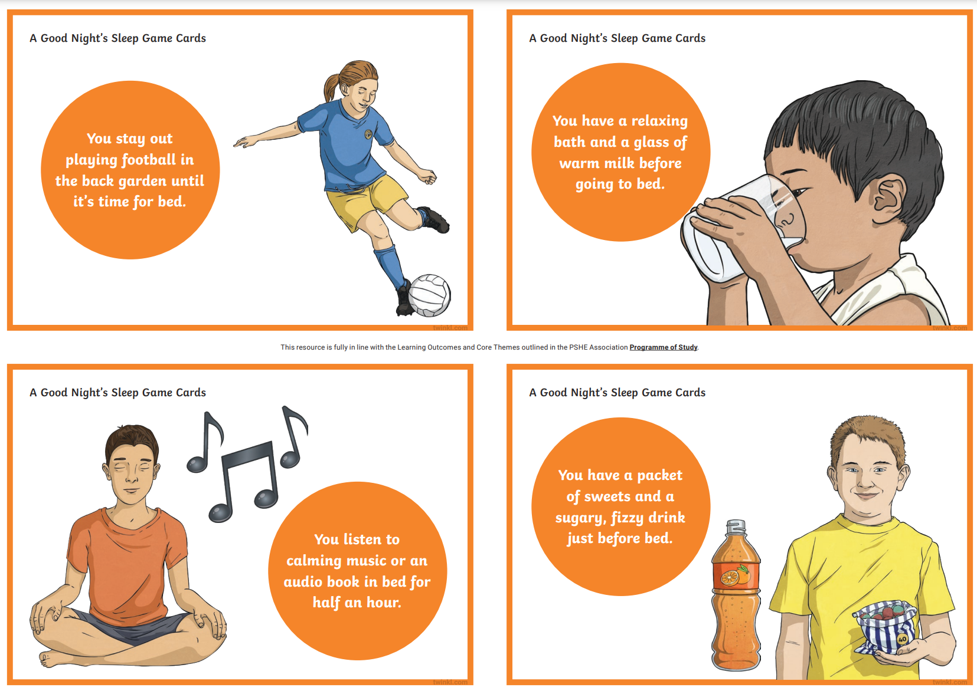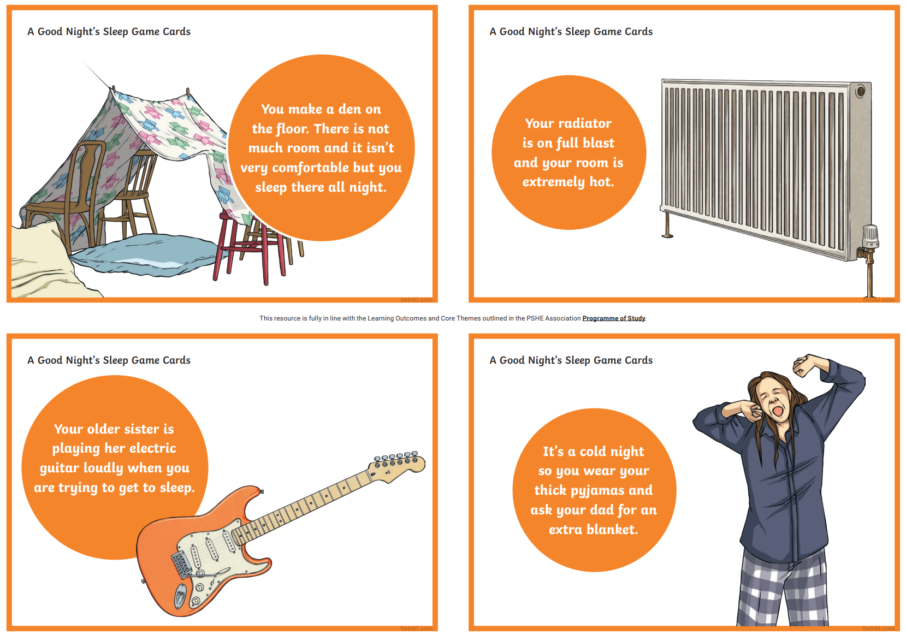
 | PE link | PE with Joe  https://www.youtube.com/watch?v=-yI7PU5Sxj0
Day 3:
 | Literacy | Grammar – fronted adverbials  https://classroom.thenational.academy/lessons/to-explore-the-functions-of-fronted-adverbials-6dhpcc
 | Maths | Same sum with decimals  https://classroom.thenational.academy/lessons/same-sum-with-decimals-6xh3jd
 | Foundation subject | Science – classify diets  https://classroom.thenational.academy/lessons/how-do-we-classify-the-diets-of-animals-6rup2c
 | PE link | Circuit activities  https://www.youtube.com/watch?v=TP4UfL_KuhQ&list=RDCMUCliBigoW1uxxMGtVIGTGwMw&index=19
Day 4: | Subject:
 | Literacy | Grammar – pronouns  https://classroom.thenational.academy/lessons/to-explore-pronouns-75h38c
 | Maths | Balancing equations using the ‘same sum’ strategy  https://classroom.thenational.academy/lessons/balancing-equations-using-the-same-sum-strategy-65hkct
 | Foundation subject | Science – how plants adapt to different environments  https://classroom.thenational.academy/lessons/how-do-plants-adapt-to-different-environments-6xj3jr
 | PE link | PE with Joe  https://www.youtube.com/watch?v=iEsZITtRiWQ
Day 5: | Subject:
 | Literacy | Grammar – relative pronouns  https://classroom.thenational.academy/lessons/to-explore-relative-pronouns-74v62c
 | Maths | Arithmetic  https://myminimaths.co.uk/arithmetic-16-practice-questions/
 | Foundation subject | Science – match the plant to its habitat. Click to enlarge.  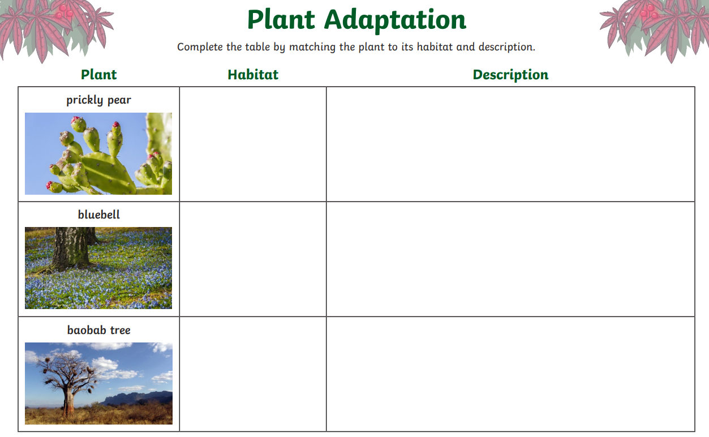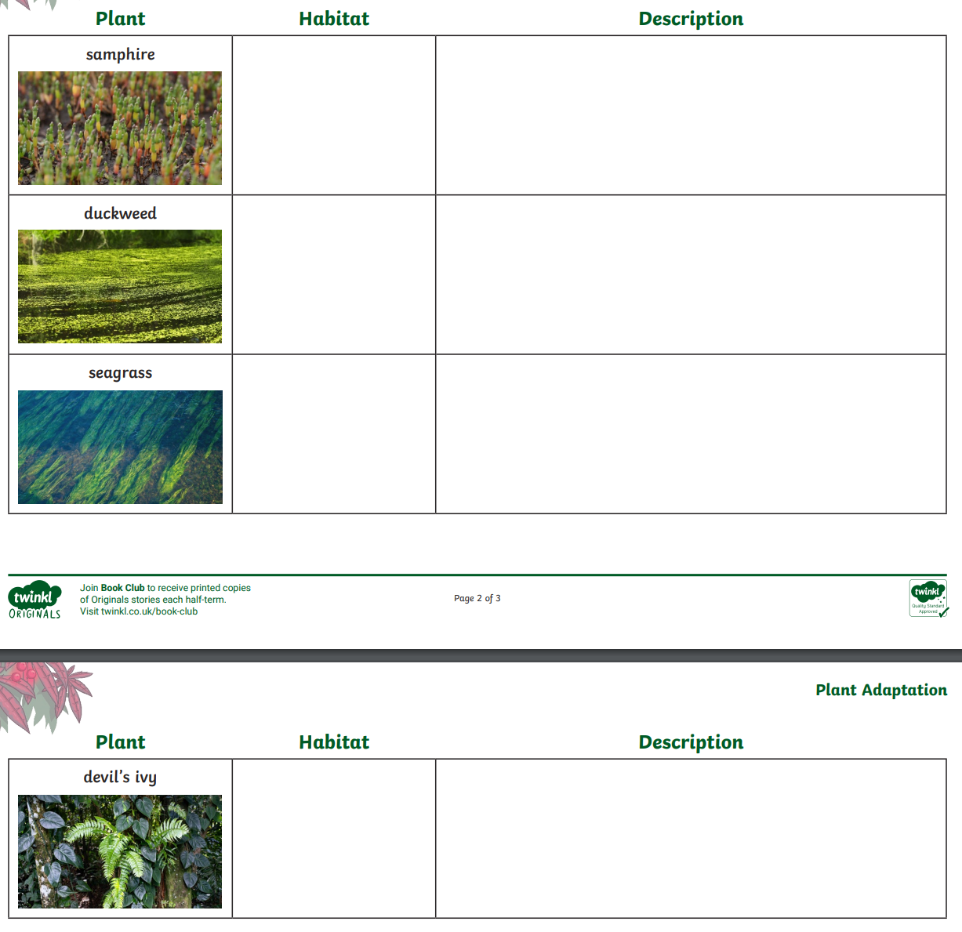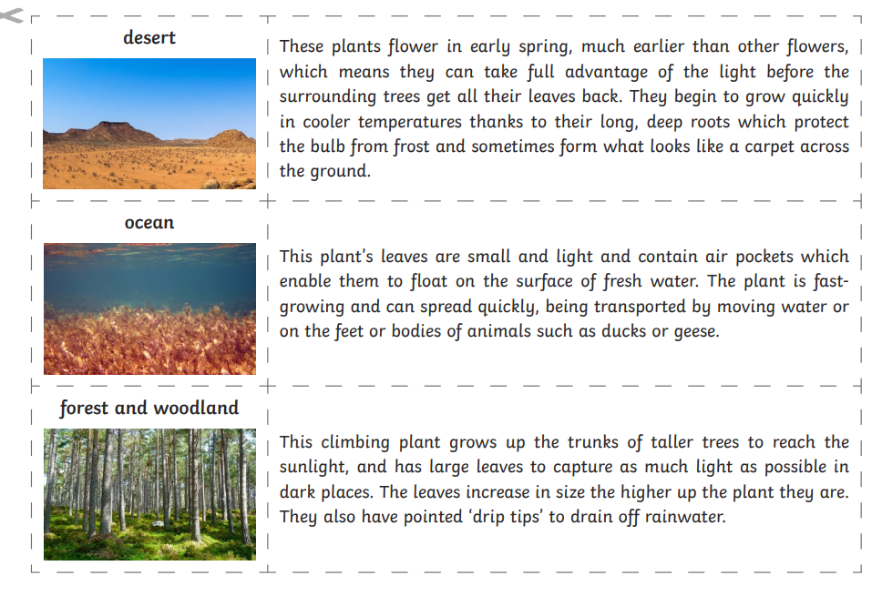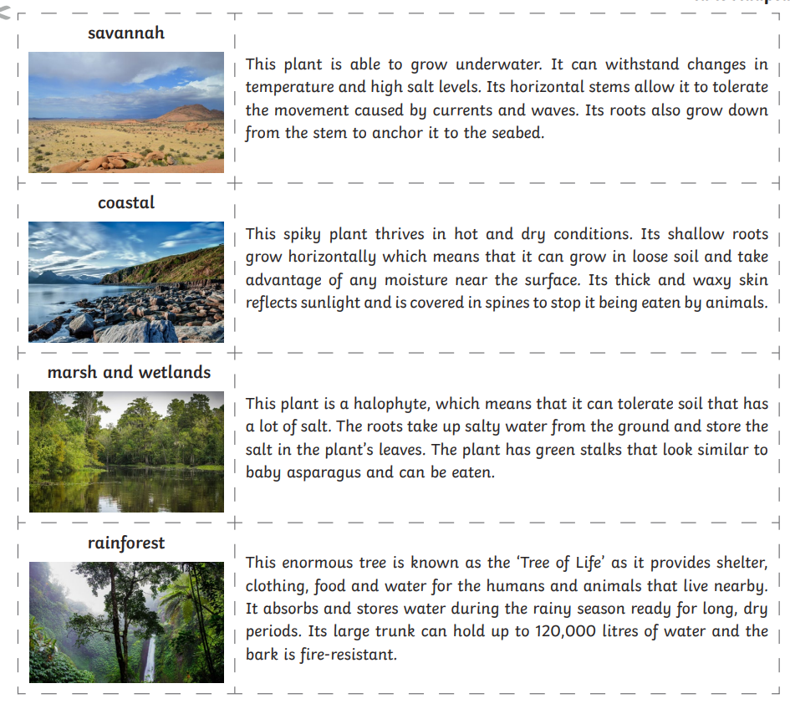
 | PE link | Standing workouts  https://www.youtube.com/watch?v=uxwaoFYxm1U

