Remote Learning Year: 3 Week beginning: 18.10.21

Email address to return completed work to:
3S remotelearning3S@cantcros.bham.sch.uk
3G remotelearning3G@cantcros.bham.sch.uk

Monday: | Subject:
 | Literacy | Explore a newspaper report  Open the document on twinkl called:  The Features of Newspapers  The features of a newspaper report are:  Headline – to catch the attention of the reader  Bi-line - the author  Date – when was it written  Images  Caption – to explain what the image is about  Range of sentence structures -  Chronological order – the order of events  Quotes – from someone who was there  Factual language  5 Ws who/what/ where/ when/ why  Identify the following features in the newspaper reports.  http://twinkl.co.uk/go  Twinkl code: EG9872
 | Maths | Recalling the 3 times table  https://classroom.thenational.academy/lessons/recalling-the-3-times-table-c8tp4d
 | Foundation subject | Science – What are the major bones in the human body?  https://classroom.thenational.academy/lessons/what-are-the-major-bones-in-the-human-body-69gpac
 | PE link | PE at home – bop it challenge  https://www.youtube.com/watch?v=CIeiNqlb3MM&t=9s
Tuesday: | Subject:
 | Literacy | Compare newspaper reports  On Twinkl read through these two newspaper reports:  - The Gorilla Gardener Newspaper Report  - Lottery Win Newspaper Report  Then, answer the following questions.  What are the newspaper reports about?  What features have been used?  What is similar?  What is different?
 | Maths | Recalling the 4 times table  https://classroom.thenational.academy/lessons/recalling-the-4-times-table-cmt64e
 | Foundation subject | Science – Make a moving skeleton  Make a moving skeleton using the sheet which is available on Twinkl. Then label the different bones in the body.  http://twinkl.co.uk/go  Twinkl code: EG5412
 | PE link | Street dance house masterclass  https://www.youtube.com/watch?v=agezOTZ1RZ8
Wednesday: | Subject:
 | Literacy | Retell an event  On Teams look at the Little Red Riding Hood document.  What is wrong here? Why is it difficult to understand?  Time conjunctions should have been used to help us understand the order of events.  First  Earlier  Next  Then  After that  Meanwhile  Now, rewrite the story so it makes sense use relative time conjunctions and a reported style.
 | Maths | Using arrays to represent the 3 and 4 times tables  https://classroom.thenational.academy/lessons/using-arrays-to-represent-the-3-and-4-times-tables-6xk38r
 | Foundation subject | Topic – Countries in South America  Find out as much as you can about these 5 countries which are in South America.  Brazil, Argentina, Chile, Peru and Ecuador.  Remember when you are searching on the internet to type ‘ks2’ or ‘kids’  For example: Brazil facts ks2 OR Brazil facts kids  See if you can find information about the following:  culture, food and climate
 | PE link | J Yoga for the classroom  https://www.youtube.com/watch?v=Td6zFtZPkJ4
Thursday:
 | Literacy | Plan an eyewitness account  Watch this video - https://www.youtube.com/watch?v=IV5LOHdrdP8  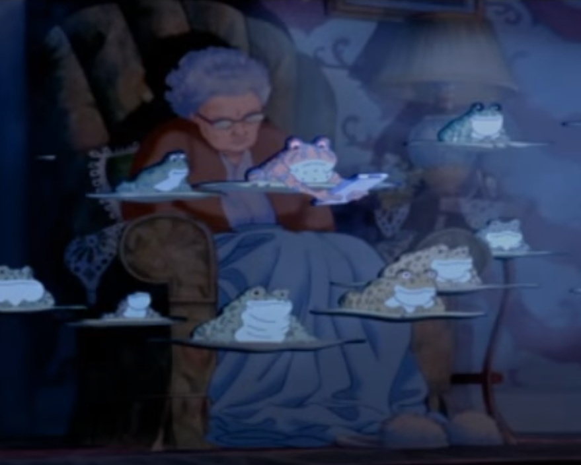  What do you think these characters would say?
 | Maths | Understanding multiplication can be completed in any order  https://classroom.thenational.academy/lessons/understanding-multiplication-can-be-completed-in-any-order-68rp6c
 | Foundation subject | RE – Create the first part of the nativity story  Find your storyboards from the nativity story which you completed last week. You may need to remind yourself of the story by going through the nativity powerpoint.  We are going to create a puppet show next week.  This week you will need to use any materials you have (card, paper, coloured pens, felt tips) to create your puppets.  You will also need to create a script to go along with it.
 | PE link | Zumba for kids - minions  https://www.youtube.com/watch?v=FP0wgVhUC9w
Friday: | Subject:
 | Literacy | To introduce apostrophes for singular possession  https://classroom.thenational.academy/lessons/to-introduce-apostrophes-for-singular-possession-6wr66d
 | Maths | Using bar models to represent known times tables  https://classroom.thenational.academy/lessons/using-bar-models-to-represent-known-times-tables-6tj62e
 | Foundation subject | Spanish – Saying your age in Spanish  https://classroom.thenational.academy/lessons/saying-your-age-in-spanish-68u38d
 | PE link | 5 alive kids workout – Joe Wicks  https://www.youtube.com/watch?v=h5PpLvMvW2s

