Remote Learning Year: 6 Week beginning: 12.07.21

Email address to return completed work to:
6A remotelearning6a@cantcros.bham.sch.uk
6D remotelearning6d@cantcros.bham.sch.uk
Day 1: | Subject:
 | Guided Understanding | 9.00 – 9.30  Children log onto Teams for live teaching  Book of the week:  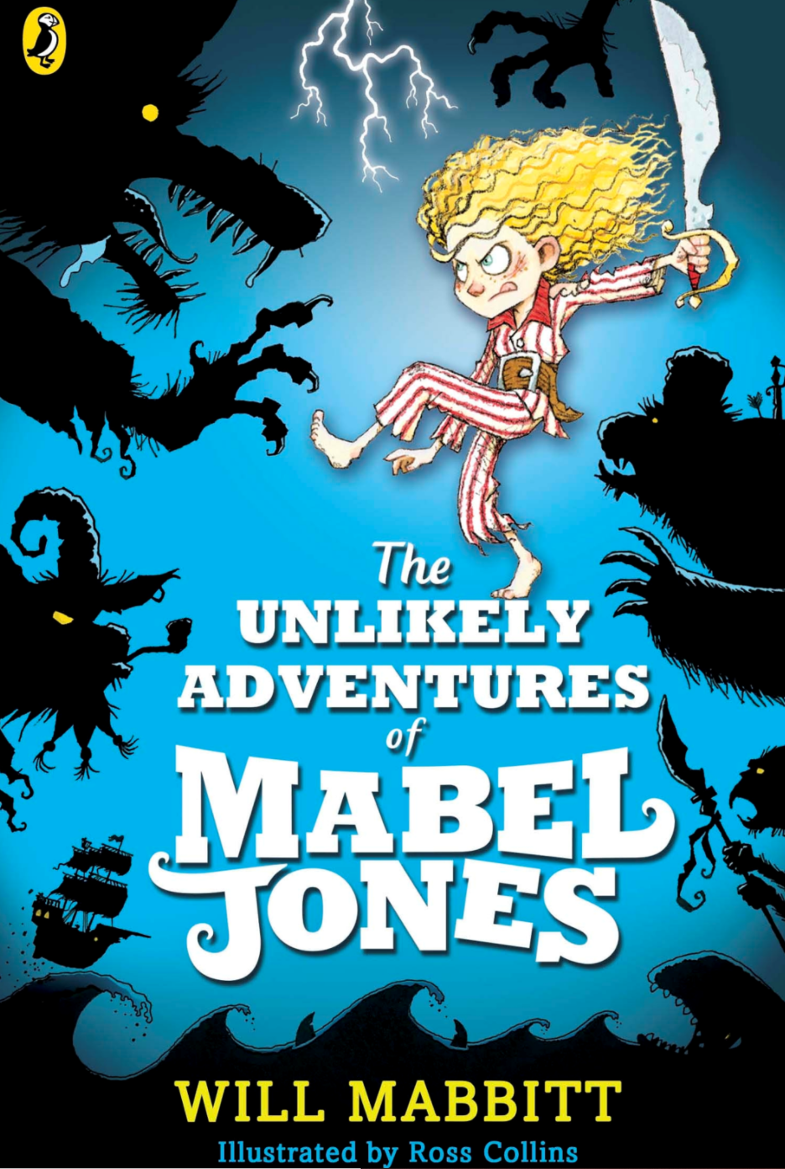  https://www.thenational.academy/library/head-on-an-adventure-with-will-mabbitt
 | Literacy | 9.30 – 10.00  Children log onto Teams for live teaching
 | Maths | 11.00 – 11.30  Children log onto Teams for live teaching  12.15 – 12.30 Times Tables Rock Stars practise
 | PE link | Super Sonic Training  https://www.youtube.com/watch?v=F_l9J1Iaz_w
 | Foundation subject | Science - Adaptation  https://classroom.thenational.academy/lessons/what-is-an-adaptation-cmw6ct
 | Foundation subject | Science - Who would live in a house like this?  Design a creature that would live in the boot of your car, or the bottom of your bag.  What special adaptations/characteristics would it have?
Day 2: | Subject:
 | Guided Understanding | 9.00 – 9.30  Children log onto Teams for live teaching
 | Literacy | 9.30 – 10.00  Children log onto Teams for live teaching
 | Maths | 11.00 – 11.30  Children log onto Teams for live teaching  12.15 – 12.30 Times Tables Rock Stars practise
 | PE link | Among Us P.E. Edition  https://www.youtube.com/watch?v=mNK0qdw73XE
 | Foundation subject | Art  Draw with Rob  Rob Biddulph draws a range of characters – have a look and choose one (or more) you would like to draw and follow this tutorial.  http://www.robbiddulph.com/draw-with-rob
 | Foundation subject | Science – The Solar System  https://www.bbc.co.uk/bitesize/articles/zsvtqfr
Day 3: | Subject:
 | Guided Understanding | 9.00 – 9.30  Children log onto Teams for live teaching
 | Literacy | 9.30 – 10.00  Children log onto Teams for live teaching
 | Maths | 11.00 – 11.30  Children log onto Teams for live teaching  12.15 – 12.30 Times Tables Rock Stars practise
 | PE link | Would You Rather? Standing WORKOUT  https://www.youtube.com/watch?v=BlIo03WZWzI
 | Foundation subject | Geography – Comparing UK, Canada and Germany  https://www.bbc.co.uk/bitesize/articles/z27bn9q
 | Foundation subject | D&T - Kite Building  What makes the best kite? Should it be flat or does a cylinder kite work too? Which material is the best? Make a kite and take it out on a walk to test it.  Take a photo of your kite and send it in.
Day 4: | Subject:
 | Guided Understanding | 9.00 – 9.30  Children log onto Teams for live teaching
 | Literacy | 9.30 – 10.00  Children log onto Teams for live teaching
 | Maths | 11.00 – 11.30  Children log onto Teams for live teaching  12.15 – 12.30 Times Tables Rock Stars practise
 | PE link | Would You Rather? Fun Fitness WORKOUT  https://www.youtube.com/watch?v=XUk6cidBCNU
 | Foundation subject | Science – living things  https://www.bbc.co.uk/bitesize/articles/ztgh7yc
 | Foundation subject | PSHE – Star qualities  Sometimes it’s hard to believe positive things about yourself and for many it is easier to believe the negative things. Taking notice of your successes, strengths, talents and interests will build your resilience, self-esteem and confidence. Use what you have achieved as a way of helping you cope with stress and adversity  It is really important to be aware of all the positive qualities you have as these make you unique.  Use the star below, or draw your own and fill it with all your positive qualities. You can choose to write, draw and / or fill it with colour!  Zoom in to enlarge
Day 5: | Subject:
 | Guided Understanding | 9.00 – 9.30  Children log onto Teams for live teaching
 | Literacy | 9.30 – 10.00  Children log onto Teams for live teaching
 | Maths | 11.00 – 11.30  Children log onto Teams for live teaching  12.15 – 12.30 Times Tables Rock Stars practise
 | PE link | Kids Workout: fun, simple, high energy moves  https://www.youtube.com/watch?v=CbsaJW94V6c
 | Foundation subject | Art  Draw with Rob  Rob Biddulph draws a range of characters – have a look and choose one (or more) you would like to draw and follow this tutorial.  http://www.robbiddulph.com/draw-with-rob
 | Foundation subject | PSHE – zoom in to enlarge  