Year 6 Parent Planner Autumn Term 2021-2022

Maths  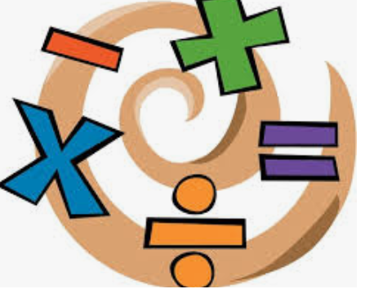 | Reading  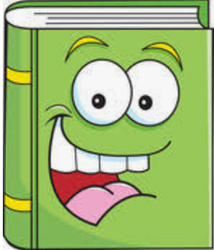 | Writing
We are learning to …  - Read, write, order and compare numbers up to 10,000,000 and determine the value of each digit  - Round any whole number to a required degree of accuracy  - Use all the multiplication tables to 12 × 12 in order to maintain their fluency  - Continue to practise the four operations for larger numbers using the formal written methods of columnar addition and subtraction, short and long multiplication, and short and long division  - Perform mental calculations, including with mixed operations and large numbers  - Solve problems involving addition, subtraction, multiplication and division  - Use estimation to check answers to calculations and determine, in the context of a problem, levels of accuracy  - Identify common factors, common multiples and prime numbers | We are learning to …  - Explain and discuss understanding of different genres of texts  - Develop strategies to work out unfamiliar language in a text  - Develop skimming and scanning skills to locate key information across a text  - Retrieve, record and present information  - Draw inferences and justify using evidence from the text  - Discuss and evaluate how authors use language, considering the impact on the reader  - Make predictions from what’s implied | We are learning to…  - Explore language, structural and punctuation features for the following units: biography and autobiography, journalistic, diary, biased and balanced arguments  - Plan and write the following: biography and autobiography, journalistic, diary, biased and balanced arguments  - Consider the audience for and purpose of the writing  - Make appropriate and effective vocabulary, grammar and punctuation choices  - Use a wide range of devices to build cohesion  - Refine and evaluate writing, including peer assessment  - Develop handwriting
Science  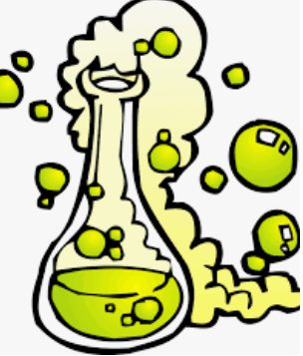 | RE/SMSC/PSHE/RRSA  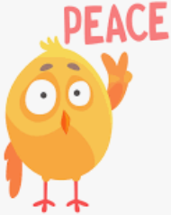 | Art/DT  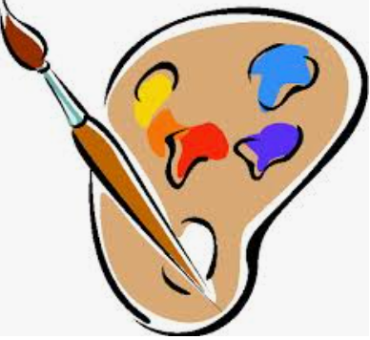
This term we will be focusing on: Biology  We will be learning about…  - Animals including humans  -identify and name the main parts of the human circulatory system, and describe the functions of the heart, blood vessels and blood  -recognise the impact of diet, exercise, drugs and lifestyle on the way their bodies function  -describe the ways in which nutrients and water are transported within animals, including humans  This term we will be focusing on: Physics  We will be learning about…  - Electricity  -associate the brightness of a lamp or the volume of a buzzer with the number and voltage of cells used in the circuit  -compare and give reasons for variations in how components function, including the brightness of bulbs, the loudness of buzzers and the on/off position of switches  -use recognised symbols when representing a simple circuit in a diagram | We are learning to…  - Compare and contrasts beliefs and commitment in the six major faiths as well as Rastafarianism and Humanism  - Explore British Values, including democracy  - Know what rights and responsibilities are  - Explore our ‘CRISP’ values  - Explore themes for health and well-being, relationships and living in the wider world | In Art we are learning to…  - Use different media (pencils, pens, charcoal etc) to practise texture techniques  - Explore proportion of body using mannequin figures  - Apply shading to show light and shadow to mannequin drawings  - Research the graffiti artist Keith Haring and create figure drawings inspired by his work  In DT we are learning to…  - Investigate fairground rides which have rotating parts, thinking about how they move, what are the components that join them together and the mechanisms that make them work  - Explore and investigate electrical motors and how they make fairground rides rotate  - Design, make and evaluate a model fairground ride with a moving part and inclusion of light component
ICT | History/Geography | PE
We are learning to…  - Explore and develop programming skills  -Programming A – Variables in games  -Programming B – Sensing  Online safety will be taught at the start and end of every unit. | We are learning to…  - Study the Victorian time period using a range of sources  - Compare and contrast the lifestyle of pauper and wealthy Victorians  - Explore living and working conditions  - Understand the significance and impact of Lord Shaftesbury workhouse findings, exploring philanthropic acts  - Explore industrial change and its impact | We are learning to…  - Develop flexibility, strength, technique, control and balance as well as compare performances in gymnastics and dance  - Play competitive games and apply basic principles suitable for attacking and defending in football  PE is on Mondays and Thursdays.  Your child must wear the appropriate PE kit.
Music | Spanish | Homework:
We are learning to…  - Develop an understanding of musical composition  - Organise and manipulating ideas within musical structures  - Reproduce sounds from aural memory | We are learning to…  - Study the unit ‘clothing’  -listen attentively to spoken language and show understanding by joining in and responding  -explore the patterns and sounds of language through songs and rhymes  -engage in conversations; ask and answer questions; express opinions and respond to those of others; seek clarification and help*  -read carefully and show understanding of words, phrases and simple writing  -understand basic grammar and punctuation | - Homework will be given out on Thursdays – to be returned on Mondays.  - Reading books will be changed weekly. Children should read daily and Reading Records are to be filled in. They are to be handed in on Mondays.  - Spellings are given out on Mondays. Children should learn their spellings for their spelling test on Fridays.  - Practise Times Table Rock Stars daily.

