Year 6 Parent Planner Spring Term

Maths | Reading  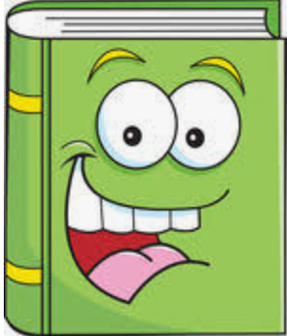 | Writing
We are learning to …  - Add, subtract, multiply and divide fractions and use common factors to simplify  - Convert between fractions, decimals and percentages  - Find percentages of amounts  - Convert between standard units, converting measurements of length, mass, volume  - Recognise that shapes with the same areas can have different perimeters and vice versa  - Recognise when it is possible to use formulae for area of shapes  - Develop test technique | We are learning to …  - Develop comprehension skills through SATs reading papers and test technique  - Explain and discuss understanding of different genres of texts  - Retrieve, record and present information  - Draw inferences and justify using evidence from the text  - Discuss and evaluate how authors use language, considering the impact on the reader  - Make predictions from what’s implied  - Distinguish between statements of fact and opinion  - Develop test technique | We are learning to…  - Explore language and structural features, plan and write a balanced argument  - Explore narrative features and write stories of different genres  - Consider the audience for and purpose of the writing  - Make appropriate and effective vocabulary, grammar and punctuation choices  - Use a wide range of devices to build cohesion  - Refine and evaluate writing, including peer assessment  - Develop handwriting
Science | RE/SMSC/PSHE/RRSA  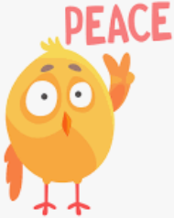 | Art/DT  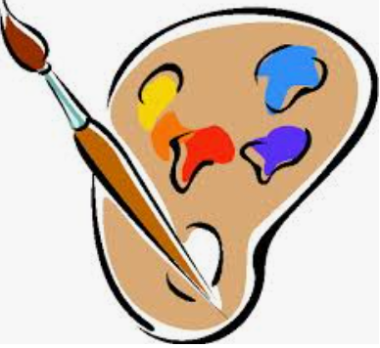
This term we will be focusing on: Physics  We will be learning about…  - Electricity  - use recognised symbols when representing a simple circuit  -compare and give reasons for variations in how components function  -explore voltage and its effect  - Light  - explain that objects are seen because they give out or reflect light into the eye  - explore why shadows have the same shape as the objects that cast them  -understand how colour is seen | We are learning to…  - Explore beliefs and meaning in Christianity.  Key question: Is anything ever eternal?  - Explore diversity and equality  - Explore resilience  - Investigate and understand how rights apply to everyday life  - Explore what rights mean to us | We are learning to…  - Draw figures and create observations using tonal techniques  - Improve art and design techniques, including drawing, painting and sculpture with a range of materials  - Investigate the artist Keith Haring and produce art in his style  - Review and revisit ideas
ICT | History/Geography | PE
We are learning to…  - Read and understand code  - Explore commands in code  - Remix code to achieve a particular outcome  - Debug a programme  Online safety will be taught at the start of each half term and as needed throughout the unit. | We are learning to…  - N/A for this term | We are learning to…  - Increase physical fitness through fitness activities.  - Practise sport techniques such as kicking, passing, throwing and catching.  - PE coach.  PE is on Wednesdays for 6D and Thursdays for 6A.  Your child must wear the appropriate PE kit with their school jumper.
Music | Spanish | Homework:
We are learning to…  - N/A for this term | We are learning to…  - N/A for this term | - Homework will be given out on Thursdays – to be returned on Mondays.  - Reading books will be changed weekly. Children should read daily and Reading Records are to be filled in. They are to be handed in on Mondays.  - Spellings are given out on Mondays. Children should learn their spellings for their spelling test on Fridays.  - Practise Times Table Rock Stars daily.

