Year 1 Parent Planner: Spring Term
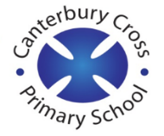

Maths  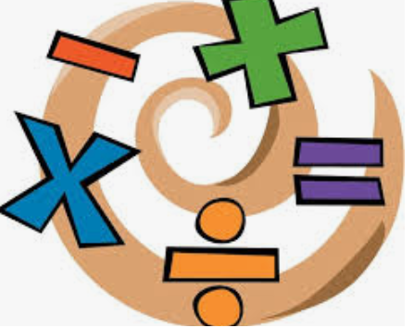 | Reading  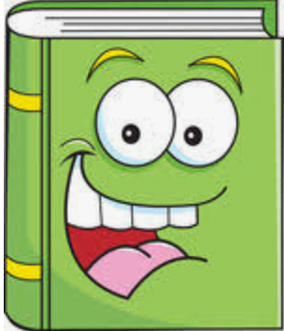 | Writing
We are learning …  - Directions and positions  - Addition and subtraction  - Capacity  - Bar modelling  - Money  - Multiplication and division  - Partitioning  - Fractions | We are learning to …  - Set 1, 2 and 3 sounds in Phonics to read real and nonsense words in preparation for the Phonics Screening Test in June 2022. | We are learning to…  - Plan and write stories  - Recounts  - Information  - Fantasy stories
Science | RE/SMSC  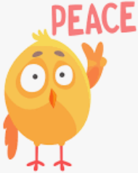 | Art/DT  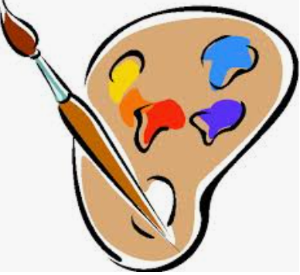
This term we will be focusing on:  Biology.  We will be learning about…  - Plants  - Structure of plants  - Identifying common plants | We are learning to…  - Creation story- Does Allah want Muslims to look after the world? | We are learning to…  - Explore printing
ICT | History/Geography | PE
N/A | We are learning…  - about Mary Seacole and Florence Nightingale and their contributions | We are learning to…  - Gymnastics  - Send and return ball skills  PE is on Tuesday and Wednesday  Your child must wear the appropriate PE kit
Music | PSHE/RRSA | Homework:
We are learning to…  - Play the recorder | We are learning to…  - Keep good self hygiene  - Making right choices  - Rights and responsibilities  - Diversity  - Contributions to classroom life | - Homework will be given out on Thursdays – to be returned on Mondays.  - Reading books will be changed weekly. Children should read daily and Reading Records are to be filled in. They are to be handed in on Mondays.  - Spellings are given out on Mondays. Children should learn their spellings for their spelling test on Fridays.  - Handwriting boards to be completed weekly at home.

